

**GROUP REPORT**

Name: Vũ Hồng Thịnh

Reg No: 001391525

Email: vt3942n@gre.ac.uk

Department: Computing

Course Code: COMP1640

Submission Date: 25/04/2024

|  |  |  |
| --- | --- | --- |
| Group 17 | | |
| Members | Reg No | Email |
| Trần Nguyễn Đông Quân | 001391506 | tq5929r@gre.ac.uk |
| Phạm Quốc Tuấn | 001391536 | pt2898u@gre.ac.uk |
| Đặng Ngọc Hiếu | 001391457 | dh6632i@gre.ac.uk |

Contents

1 Project Introduction. 4

2 User Requirement 5

3 Design 11

3.1 Use-case Diagram 11

3.2 Database Diagram 13

3.3 Class Diagram 14

3.4 Activity Diagram 15

3.5 Sitemap 16

3.6 Mockup 17

4 Agile Method 18

4.1 Roles 18

4.2 Tools 18

4.3 Product Backlog 19

4.4 Sprint Backlog 20

4.5 Sprint Event 21

4.6 Burn down Chart 32

5 Testing: Test Plan; Test Log; Sufficient Test Data to thoroughly test; Evidence of testing finding errors; Test Items linked to user stories in the product backlog. (Anything to prove that you seriously tested your application every sprint.) 34

6 Product: Screenshots of your actual application and its functions. (As detailed as possible.) 39

6.1 Server-Side 39

6.1.1 Project Structure 39

6.1.2 Model **Error! Bookmark not defined.**

6.1.3 Repository **Error! Bookmark not defined.**

6.1.4 DTO **Error! Bookmark not defined.**

6.1.5 Services **Error! Bookmark not defined.**

6.1.6 Controller **Error! Bookmark not defined.**

6.1.7 Auto Mapper **Error! Bookmark not defined.**

6.1.8 DB Context **Error! Bookmark not defined.**

6.1.9 Configuration **Error! Bookmark not defined.**

6.2 Client-Side 56

7 Materials 69

8 References (if any). 69

Figure 1: Student Use-Case 11

Figure 2: Coordinator Use-Case 12

Figure 3: Marketing Manager Use-Case 13

Figure 4: ERD 14

Figure 5: Class Diagram 14

Figure 6: Login Diagram 15

Figure 7: Change Password Diagram 15

Figure 8: User Contribution Diagram 15

Figure 9: Coordinator View and Comment Diagram 15

Figure 10: Marketing Manager Download File Diagram 16

Figure 11: Site Map 16

Figure 12: Mockup 17

Figure 13: Color Palate 17

Figure 14: Jira 19

Figure 15: Sprint Backlog 1 20

Figure 16: Sprint Backlog 2 20

Figure 17: Sprint Backlog 3 20

Figure 18: Sprint Backlog 4 20

Figure 19: Sprint Backlog 5 21

Figure 20: Sprint 1 Retrospective 27

Figure 21: Sprint 2 Retrospective 28

Figure 22: Sprint 3 Retrospective 29

Figure 23: Sprint 4 Retrospective 30

Figure 24: Sprint 5 Retrospective 31

Figure 25: Sprint 1 Burndown Chart 32

Figure 26: Sprint 2 Burndown chart 32

Figure 27: Sprint 3 Burndown Chart 33

Figure 28: Sprint 4 Burndown Chart 33

Figure 29: Sprint 5 Burndown Chart 34

Figure 30: Project Structure. 39

Figure 31: Project Structure. 40

Figure 32: Project Structure 41

Figure 33: Get Contributior 41

Figure 34: Get Content(read file) 42

Figure 35: Get Contribution by ID 42

Figure 36: Create Contribution 43

Figure 37: Update Contributor 44

Figure 38: Update Contributor Status 45

Figure 39: Update Contributor Comment 45

Figure 40: Check Submit Date 46

Figure 41: Check Published Date 46

Figure 42: Get Faculty 46

Figure 43: Get Faculty by ID 47

Figure 44: Get Student 47

Figure 45: Get Contribution 47

Figure 46: Get Submit Date 48

Figure 47: Get Complete Date 48

Figure 48: Dashboard 49

Figure 49: Get Report 49

Figure 50: Get Report without comment 49

Figure 51: Login Function 50

Figure 52: Create Function 51

Figure 53: Get User 51

Figure 54: Get Email 52

Figure 55: Get Role 52

Figure 56: Get User By LoginName 53

Figure 57: Update User 54

Figure 58: Change Password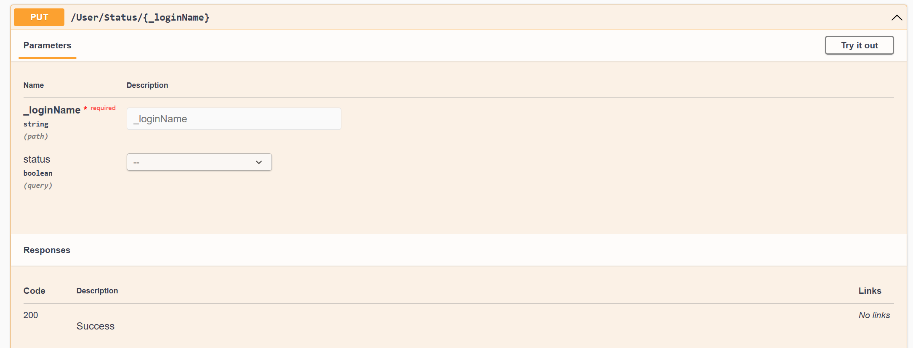 54

Figure 59: Update User Status 55

# Project Introduction.

* A beloved tradition that promotes the feeling of community and displays student talent is the yearly university magazine. On the other hand, handling contributions from pupils in a big university can be difficult and time-consuming.
* This project aims to transform the process of gathering and selecting student submissions for the magazine by presenting a safe and intuitive web-based solution. Because of the system's strong role-based access management, all stakeholders may work with it in a simplified and effective manner.
* Important features:
  + Centralized Platform: Using a single, easy to use platform that is available from any device, simplify the contribution process for educators, administrators, and students.
  + Safe Role-Based Access: Every user will be assigned a role with particular rights. Contributions may be made by students, faculty entries may be managed by marketing coordinators, and the entire process is supervised by the university marketing manager.
  + Smooth Communication: Faculty Marketing Coordinators may communicate directly with students through the system for editing and comments, and they can also receive email notifications when new contributions are made.
  + Control and Transparency: Before submitting, students must accept the terms and conditions. A defined timeframe for submissions and revisions is ensured by closure dates.
  + Enhanced Reporting: With built-in statistics capabilities, examine submission patterns and learn more about student involvement.   
    visitor Access: A faculty member may assign visitor credentials to see particular reports.
  + Downloadable Archive: All selected contributions may be downloaded as a ZIP file by the University Marketing Manager for additional processing following the final closing date.
  + Security and Scalability: The system is designed to be scalable in order to accommodate future increases in the number of students and the size of the university. Strong security measures are in place to safeguard user data and student work.
* **In this project the technology that we use is:**
  + Design: Figma
  + Backend (API MVC): ASP.Net Core with Entity Framework
  + Frontend: Html, SCSS with Angular Framework
  + Database: Microsoft SQL server

# User Requirement

* ASSUMPTION
  + A marketing coordinator can belong to many departments
  + A contribution within a department can only be reviewed and commented on by a marketing coordinator
  + The system only works with MS Word and Image JPG files. Checking the file type is not covered by this program.
  + Communication between Marketing Coordinator and Contributor is via Email, other communication channels are not implemented in this program.
  + Any changes to user information will be affected the next time you log in
  + Do not delete users on the database, it only has the function to change the user status to inactive
* Functions in the program manage student contributions
  + View contribution information (for faculty Guest accounts)
  + After logging into the system
  + The user (Guest) will be redirected to the contributions list page with a selection screen with many parameters to find contributions including
    - Start day
    - End date
  + User selects parameters and filters information
  + The system presents a list of contributions according to the values of the selected parameters
  + User selects 1 contribution to view (select only 1)
  + The system presents contribution information.
  + Users can view the content of MSWord files or images in selected contributions
  + Create a contribution (for contributor accounts)
  + After logging into the system
  + The user (contributor) accesses the contribution section and creates a new section including the following information:
    - * Title
      * Description for contribution
      * Users upload files containing content (MS Word or Images)
  + User selects save function
  + The system saves information, creation date, user code and changes the contribution status to Saved
  + The system automatically generates a contribution code in the form studentid+yy-mm-dd+xxx where xxx are digits in the order 001, 002, 003,...
* Update contribution section (for contributor accounts)
  + After logging into the system
  + User selects My Contributions
  + The system will display a list of user contributions in descending chronological order including categories
    - * Incomplete contributions (Saved or Editing)
      * Submitted contributions (Submitted)
      * Baselined contribution
  + The user selects a contribution in the saved section
  + The system presents information about the selected contribution
  + User edits content
  + User saves
  + The system saves information and update date
    - * Users can also select Cancel if they want to discard this contribution. The system will change the contribution status to Cancel and save the Cancel date on the update date
      * Submit your contribution for review (for contributor accounts)
      * Before the contribution deadline expires and when the contribution information has been completed, users can select the Submit function to notify the
* Marketing Coordinator to view and comment.
  + After logging into the system
  + User selects My Contributions
  + The system will display a list of user contributions in descending chronological order including categories
    - * Incomplete contribution (Saved = 0 or Editing = 1) Status = 0
      * Submitted contribution 2
      * Baselined contribution 3
  + The system presents information about the selected contribution
    - User selects Submit function (user must choose to agree to Terms and Conditions - only required once)
    - The system requires confirmation and changes the contribution's status to Submitted, saving the last submission date
    - The system sends an email to the coordinator to notify that a contribution has been submitted
* View and comment (for Marketing Coordinator accounts)
  + After logging into the system
  + User (Marketing Coordinator) selects Contributor's contribution
  + The system will display a list of contributor contributions in departments and user-managed groups in descending chronological order, including the following types:
    - Submitted contribution 2
    - Baselined contribution 3
  + Information about contributions presented on the inclusion list
    - Donation code
    - Contributor code
    - Department
    - Last submission date
    - Title of the contribution
    - Number of submissions
  + User selects a contribution to view and comment on
  + The system presents information about contributions
  + Users view and fill in comments about contributions
  + User saves
  + The system saves information and comment date on the update date and changes the contribution status to Editing
  + The system sends an email to the author of the contribution to notify the user of the need to edit (see Update contributions)
* Complete contribution (for Marketing Coordinator accounts)
  + After everything is done and before the deadline for completion, the user (coordinator) will change the status of the contribution to completed (baselined) and select the Publish function to the school website if necessary
  + Check and archive contributions (for University Marketing Manager accounts)
  + After logging into the system
  + The user (University Marketing Manager) selects the contribution list
  + The system will present a selection screen with multiple parameters to find the included contributions
    - Start day
    - End date
    - Faculty (allow multiple selection)
    - Status (Submitted or Baselined)
  + Users Select parameters and proceed to filter data
  + The system finds and presents a list of included contributions
    - Donation code
    - Contributor code
    - Date submitted
    - Contribution title
  + User selects one or more contributions and selects Export
  + The system will filter the contributions and take the file (MS Word or Image), compress it into a Zip file and save it to the folder specified in System Configuration
  + System configuration management
* Manage contribution time
  + After logging into the system
  + The user (Admin) selects the configuration management function
  + The system presents a screen with information
    - Submit valid time (SUBMIT_TIME) calculated in days from the date the contribution was saved
    - Valid time to complete(BASELINE_TIME) calculated in days from the date the contribution was saved
    - The appropriate time to comment (COMMENT_TIME) is calculated by the number of days since Submitting the contribution
  + Folder to save compressed files containing contributions
  + User edits information and Saves
  + The system checks the validity of data and saves information and modification date
  + Note: BASELINE_TIME must be at least 7 days after SUBMIT_TIME
  + SUBMIT_TIME cannot be edited once at least one contribution has been submitted
  + BASELINE_TIME cannot be edited once there is at least one completed contribution
* User management
  + View and edit user information
  + After logging into the system
  + The user (Admin) chooses the user management function
  + The system presents a list of users in the system including
    - Login name (Login name)
    - Full name (fullname)
    - Role
    - Status (status: active, Inactive)
  + Admin chooses 1 user
  + The system presents the user information editing screen, including
    - Username (read only)
    - Full name
    - Role(read only)
    - Status
    - Faculty
      * is read only if it is a Contributor
      * not present if the role is University Marketing Manager)
    - Contributor group of contributors in the department
    - Password
  + Admin edits information and saves
  + The system saves the information (password encryption with Md5 key) and returns to the screen containing the user list
  + Be sure to check to see if the list of departments (if it is a marketing coordinator) is the same as another marketing coordinator
* Create new user
  + After logging into the system
  + The user (Admin) chooses the function to create a new user
  + New user creation screen presentation system included
    - Role (Contributor, Marketing Coordinator, Marketing Manager)
    - Full name
      * If you are a Contributor, you can select a student's name from the student list
    - Login name (you can request a name that does not overlap with an existing user)
      * If you are a Contributor, you will be allowed to take student_id as the name you are entering
    - Status: Default is active
    - Faculty: allows you to choose a faculty
      * If you are a Contributor, the department will be filled in as that student's department and editing will not be allowed
      * If it is University Marketing Manager, the department is NULL
      * If you are a Coordinator, you are allowed to choose multiple departments
    - Password
    - Contributor group of a Faculty
    - Admin fills in and saves user information (the system encrypts the password with md5 before saving), date of creation
  + The system saves the information and resets the new user creation screen
  + Be sure to check to see if the list of departments (if it is a marketing coordinator) is the same as another marketing coordinator
* System access
  + - Log in
      * In the system's main screen (dashboard)
      * User selects Login function
      * Login screen presentation system includes
      * User name
      * Password
      * User fills in information and logs in
      * The system checks whether the login information is valid? Otherwise, an error will be reported
      * If the login information is valid, the system will present a screen depending on the role of the login person and the login name on the screen.
    - Log out
      * User selects logout function
      * The system confirms the logout and logs out of the system
      * The system will display the main screen (dashboard) again.
      * The login name will be removed from the screen
    - Present information
      * Manage main screen (Dashboard)
      * In the main screen, a presentation chart appears
      * Total contributions by each Faculty in the current year (Bar chart)
      * Contribution ratio of each department in the current year (Pie chart)
* Report
  + After logging into the system
  + The user (University Marketing Manager) selects the Report function
  + Screen presentation system includes options
    - Start year
    - End year
    - Statistics report (Statistics report)
    - Exception reports
  + User selects statistical report
  + The system presents information about contributions in format
    - Year, Faculty, Total number of contributions, % contribution, Total number of contributors
  + User selects exception report
  + The system presents information about contributions in format
    - List of contributions without comments
      * Year, Faculty, Contributor, Contribution title
    - List of contributions with no comments after 14 days
      * Year, Faculty, Contributor, Contribution title

# Design

## Use-case Diagram

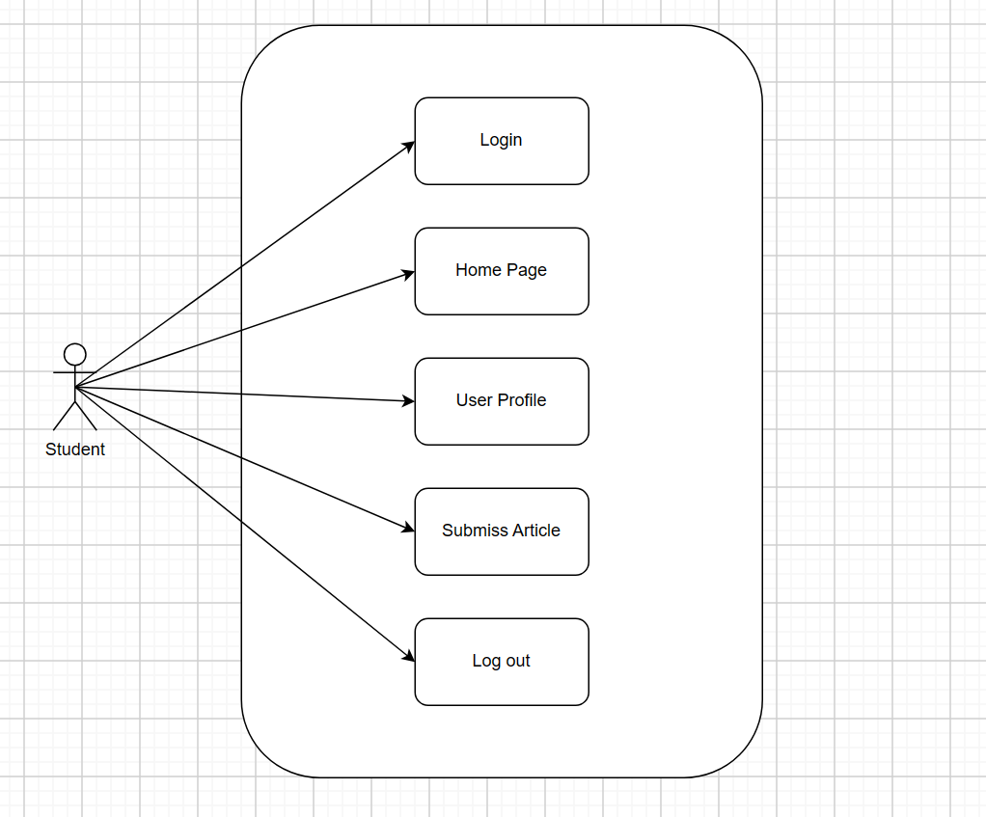

Figure 1: Student Use-Case

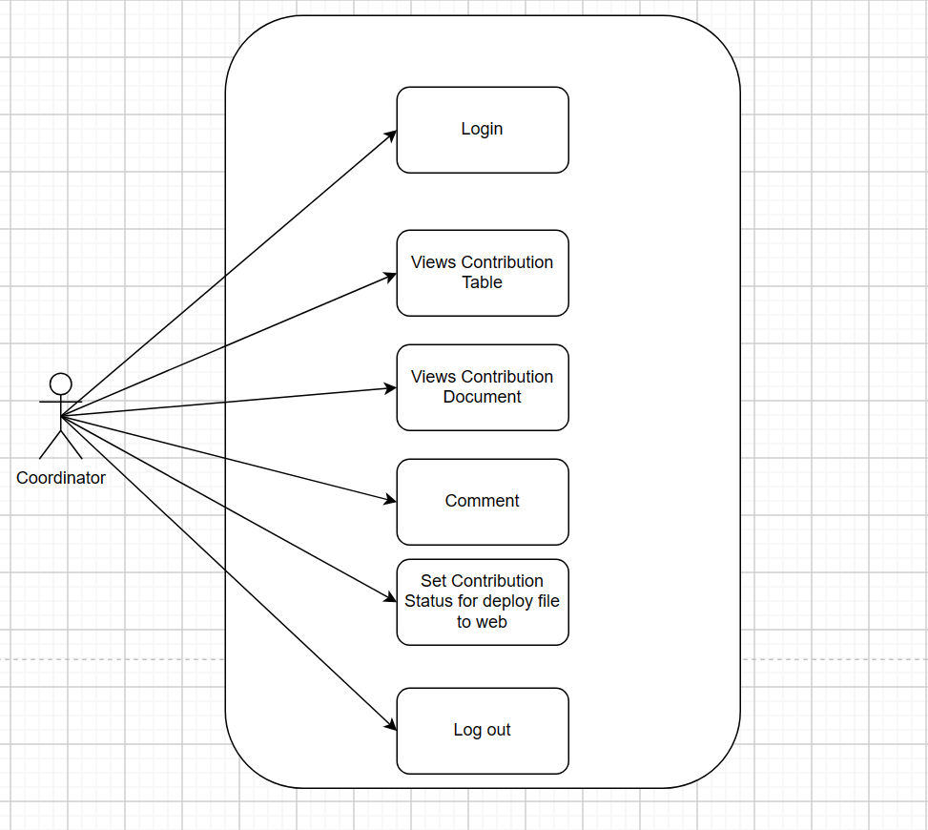

Figure 2: Coordinator Use-Case

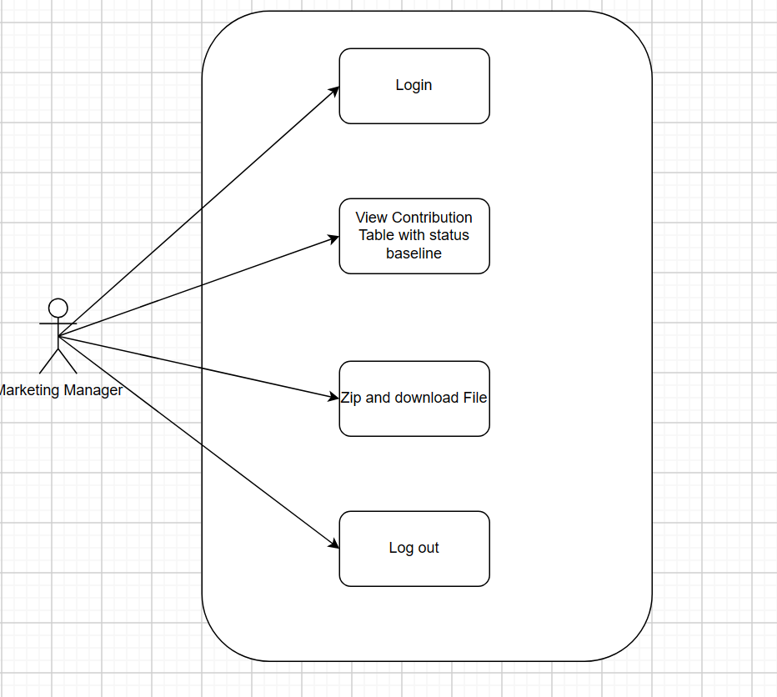

Figure 3: Marketing Manager Use-Case

## Database Diagram

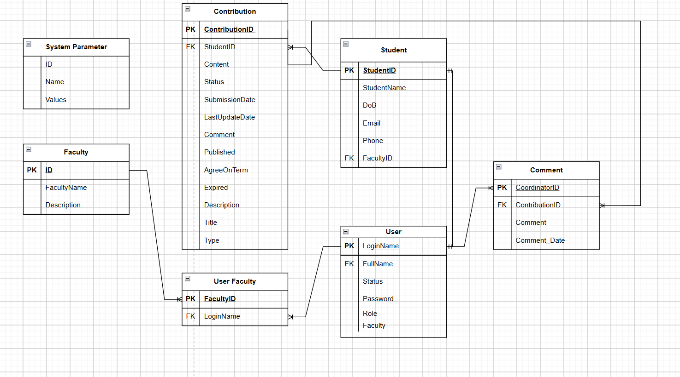

Figure 4: ERD

## Class Diagram

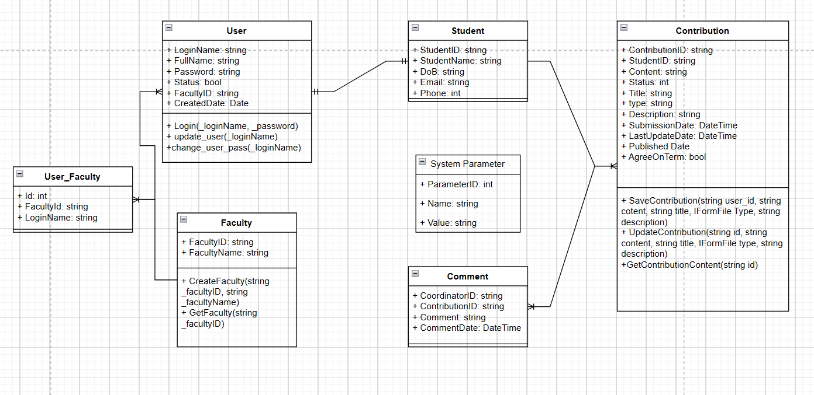

Figure 5: Class Diagram

Bỏ user faculty

## Activity Diagram

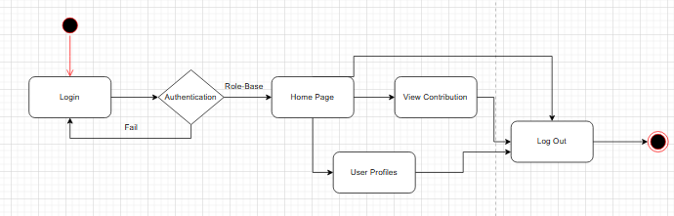

Figure 6: Login Diagram

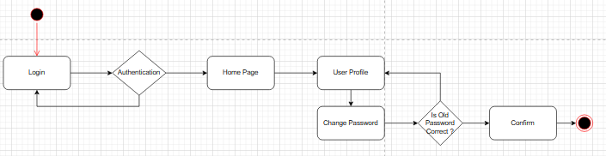

Figure 7: Change Password Diagram

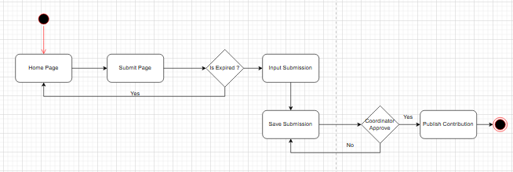

Figure 8: User Contribution Diagram

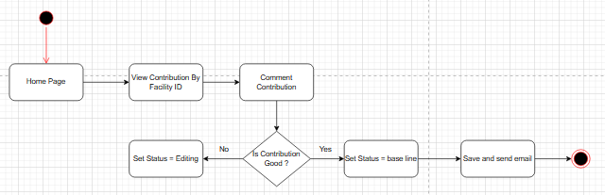

Figure 9: Coordinator View and Comment Diagram

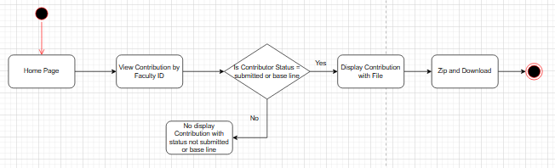

Figure 10: Marketing Manager Download File Diagram

## Sitemap

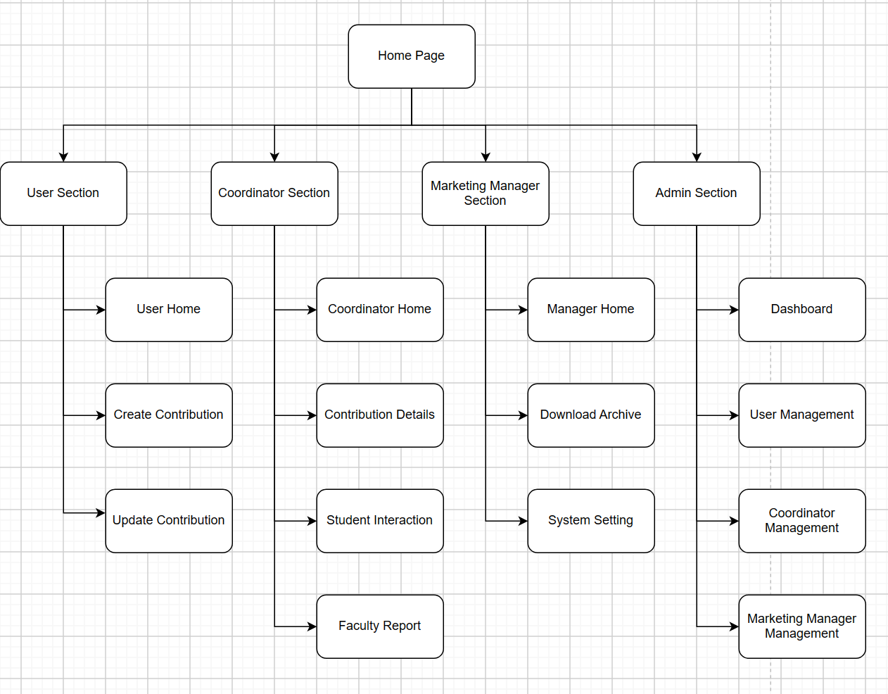

Figure 11: Site Map

## Mockup

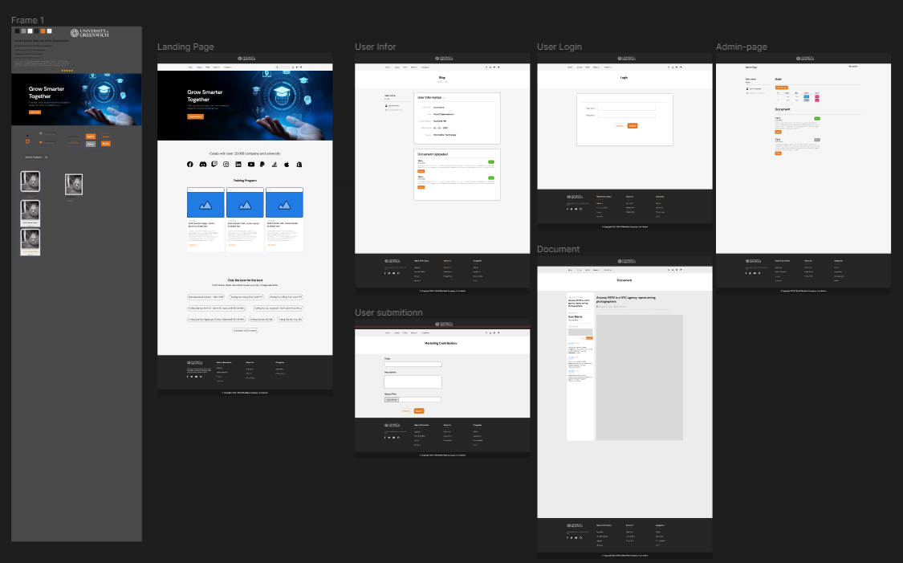

Figure 12: Mockup

The first thing to do to make the group's website interactive with users is to create a UI. The team decided to use Figma as a tool to be able to build the UI

To make it easier to design UI in Figma, I first created the components and styles in Figma's libaries so that when building, I only need to take them out and use them, without having to create them from scratch.

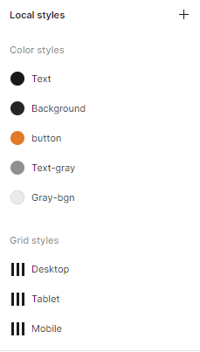

Figure 13: Color Palate

Figma design will include relevant UIs that the website needs such as User-page, landing-page, contributed product display page, Admin-page, ...

# Agile Method

### Roles

|  |  |
| --- | --- |
| ***Name*** | ***Roles*** |
| Trần Nguyễn Đông Quân | Scrum Master, Back-End Developer, Database Designer |
| Vũ Hồng Thịnh | Product owner, Front-End Developer, Information Architecture |
| Phạm Quốc Tuấn | Designer, Front-End Developer |
| Đặng Ngọc Hiếu | Designer, Front-End Developer, Tester |

### Tools

* Jira is an application designed to facilitate the tracking and management of issues, bugs, and projects for any kind of company. Jira is innovative, user-friendly, and focused on business results in its design.
  + What are Jira's primary features?
  + Oversee and track the development of the project.
  + Handle any problems with features, work, upgrades, or bugs.
  + Use the JIRA Query Language filter to rapidly search.
  + Create a workflow that satisfies each project's criteria.
  + offers a wide range of statistical reports with a wide variety of graphics that are appropriate for a wide range of projects and user types.
  + Integrate other systems (such email, excel, RSS, etc.) with ease.
  + ability to function on the majority of hardware, operating systems, and databases
* What factors led the team to choose Jira as their platform?
  + Selecting from a wide variety of projects with various goals is simple.
  + Organize and assign tasks to team members with ease.
  + Establish a productive workflow
  + Managing several software projects at once is simple.
  + Using the JIRA Query Language filter, searching is quick.
  + Producing project analysis reports is simple, fast, accurate, and efficient.
  + More than 950 add-ons offer sophisticated functionality.
  + The user interface is user-friendly, intuitive, simple to use, and appropriate for all kinds of users.

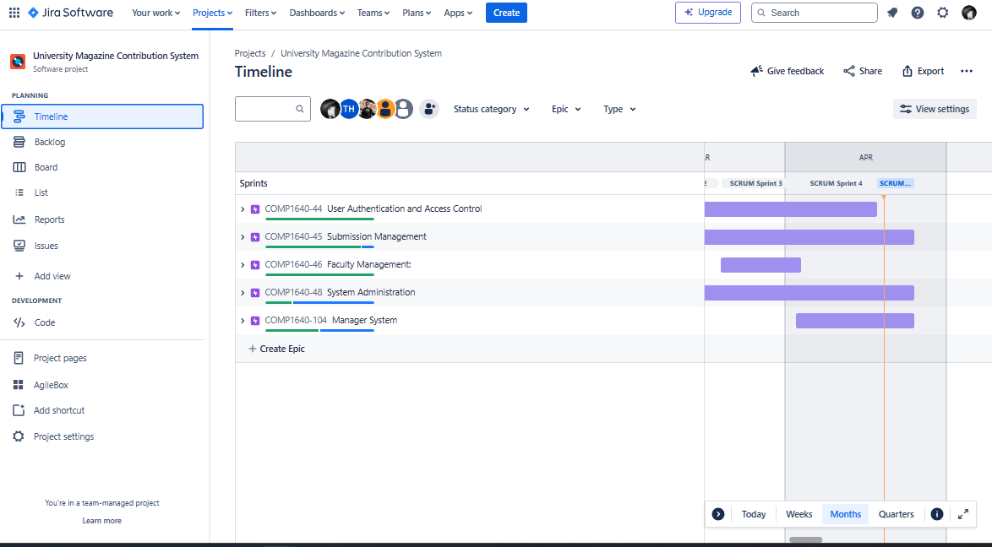

Figure 14: Jira

### Product Backlog

Product backlog is a list of requirements and features necessary to carry out the project. The product backlog creates an overview of what needs to be done in the project.

|  |  |  |
| --- | --- | --- |
| Requirement | User Story | Importance |
| MANAGE STUDENT CONTRIBUTIONS | View contribution information (for faculty Guest accounts) | NORMAL |
| Create a contribution (for contributor accounts) | HIGH |
| Update contribution section (for contributor accounts) | NORMAL |
| Submit your contribution for review (for contributor accounts) | HIGH |
| View and comment (for Marketing Coordinator accounts) | NORMAL |
| Complete donation (for Marketing Coordinator accounts) | LOW |
| Check and archive contributions (for University Marketing Manager accounts) | HIGH |
| System configuration management | Manage contribution time | NORMAL |
| User management | HIGH |
| Present information | HIGH |

### Sprint Backlog

Sprint Backlog is an item that needs to be completed during the Sprint, which can be considered a subset of the Product Backlog, a collection of selected tasks that need to be completed within a certain period of time.

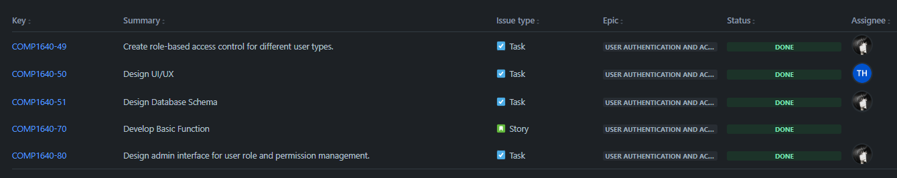

Figure 15: Sprint Backlog 1

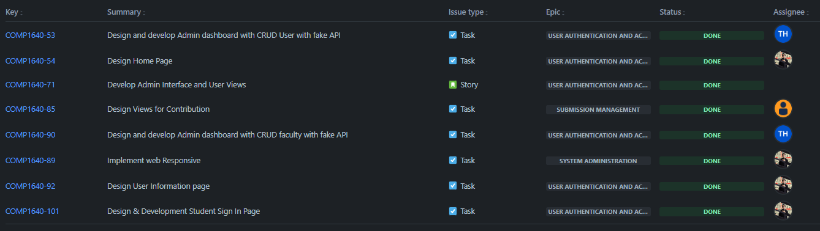

Figure 16: Sprint Backlog 2

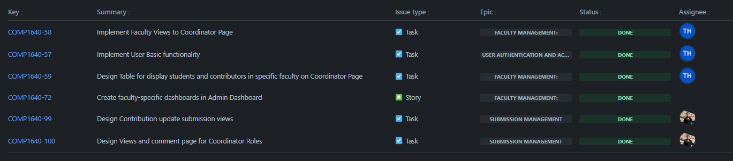

Figure 17: Sprint Backlog 3

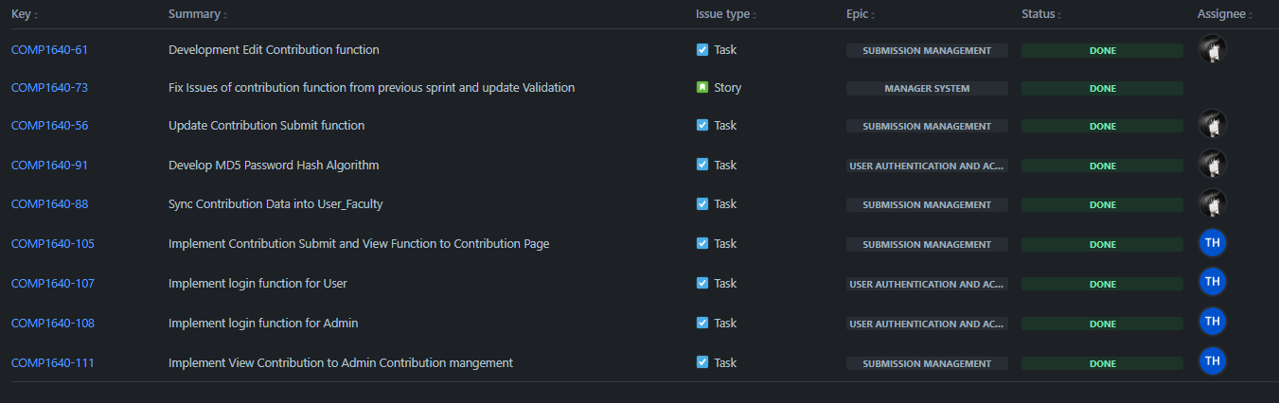

Figure 18: Sprint Backlog 4

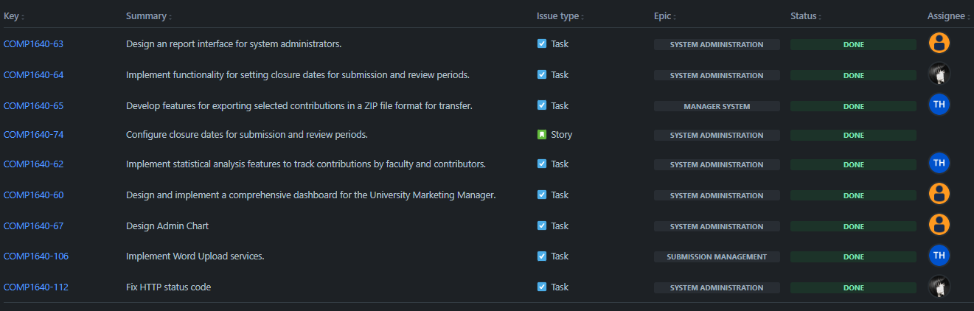

Figure 19: Sprint Backlog 5

### Sprint Event

1. Sprint Planning

Sprint planning will take place in the form of a team meeting on the start date of the new sprint. The team discusses and reviews the product backlog and prioritizes goals for the next sprint.

**Sprint 1: February 21st, 2024 - March 7th, 2024**

Discuss the proposed requirements based on user stories.

Establish each team member's role with requirements.

Discuss the requirements that need to be implemented in the current sprint:

* Review and assign members in UI/UX design.
* Review and assign members to design the Database and basic functions of the system.
* Create role-based access control for different types of users.
* Design an admin interface to manage user roles and permissions.

Summarize the implementation process at the end of each sprint to come up with a plan for the next sprint.

**Sprint 2:** **March 6th, 2024 - March 20th, 2024**

Review the product backlog in the old sprint, set the priority for that product backlog in the current sprint.

Discuss the requirements that need to be implemented in the current sprint:

* Interface design and programming: Home Page; View of Contribution; Admin Page; User Page; Login Page.
* Responsive design
* Set up some basic functionality with fake API for the website.

Establish each team member's role with requirements.

Summarize the implementation process at the end of each sprint to come up with a plan for the next sprint.

**Sprint 3: March 20th, 2024 - April 3rd, 2024**

Review the product backlog in the old sprint, set the priority for that product backlog in the current sprint.

Discuss the requirements that need to be implemented in the current sprint:

* Implement Faculty Views to Coordinator Page.
* Implement User Basic functionality.
* Design Table for displaying students and contributors in specific faculty on Coordinator Page.
* Create faculty-specific dashboards in Admin Dashboard
* Design Contribution updates submission views.
* Design Views and comments page for Coordinator Roles

Establish each team member's role with requirements.

Summarize the implementation process at the end of each sprint to come up with a plan for the next sprint.

**Sprint 4: April 3rd, 2024 - April 17th, 2024**

Review the product backlog in the old sprint, set the priority for that product backlog in the current sprint.

Discuss the requirements that need to be implemented in the current sprint:

* Development Edit Contribution function.
* Fix Issues of contribution function from previous sprint and update Validation
* Update Contribution Submit function.
* Develop MD5 Password Hash Algorithm
* Sync Contribution Data into User Faculty
* Implement Contribution Submit and View Function to Contribution Page
* Implement login function for User.
* Implement login function for Admin.
* Implement View Contribution to Admin Contribution management.

Establish each team member's role with requirements.

Summarize the implementation process at the end of each sprint to come up with a plan for the next sprint.

**Sprint 5: April 18th, 2024 - April 24th, 2024**

Review the product backlog in the old sprint, set the priority for that product backlog in the current sprint.

Discuss the requirements that need to be implemented in the current sprint:

* Design a report interface for system administrators.
* Implement functionality for setting closure dates for submission and review periods.
* Develop features for exporting selected contributions in a ZIP file format for transfer.
* Configure closure dates for submission and review periods.
* Implement statistical analysis features to track contributions by faculty and contributors.
* Design and implement a comprehensive dashboard for the University Marketing Manager.
* Design Admin Chart
* Implement Word Upload services.
* Fix HTTP status code.

Review the remaining tasks in the Product Backlog and Backlog to select the top tasks. Select only the most important tasks.

The team will then estimate the time for each task using Planning Poker techniques or other methods.

Based on the capacity of each member, tasks will be assigned and pushed to the "To Do" column.

During the sprint, task progress will be tracked on the Task Board. Daily meetings will help remove roadblocks.

At the end, the team will review the completed work against the set goals

1. Daily Meeting

Daily meeting is a group meeting process that takes place every day during the implementation of a sprint. Meetings will help track the progress of the sprint and complete it in the best way.

1. Sprint Review

At the end of each sprint, each department such as the product owner or scrum team and stakeholders will jointly hold a sprint review meeting to check and ensure product performance and progress.

At this stage, the Product Owner will confirm whether the created functionality meets the requirements of the sprint and whether the sprint is completed or not.

**Sprint 1 Review:**

**Proposed Requirements:**

* Reviewed and discussed proposed requirements based on user stories.
* Established team members' roles with requirements.
* Identified requirements to be implemented in the current sprint.

**Implemented Requirements:**

* Reviewed and assigned members in UI/UX design.
* Reviewed and assigned members to design the Database and basic functions of the system.
* Created role-based access control for different types of users.
* Designed an admin interface to manage user roles and permissions.

**Summary of Implementation Process:**

* Team successfully reviewed and assigned roles for the initial phase of development.
* Core functionalities related to user roles and permissions were implemented.
* Next Sprint Plan: Prioritize tasks for interface design and basic functionality implementation.

**Sprint 2 Review:**

**Review of Product Backlog:**

* Prioritized backlog items from the previous sprint.

**Implemented Requirements:**

* Designed and programmed various interface components including Home Page, View of Contribution, Admin Page, User Page, and Login Page.
* Ensured responsive design for different devices.
* Set up basic functionality with a fake API for the website.

**Summary of Implementation Process:**

* Interfaces for key pages were successfully designed and implemented.
* Basic functionality was set up to lay the foundation for further development.
* Next Sprint Plan: Focus on implementing additional functionalities and refining existing features.

**Sprint 3 Review:**

**Review of Product Backlog:**

* Prioritized backlog items from the previous sprint.

**Implemented Requirements:**

* Implemented Faculty Views on Coordinator Page.
* Implemented basic functionality for users.
* Designed tables for displaying students and contributors in specific faculties on the Coordinator Page.
* Created faculty-specific dashboards in the Admin Dashboard.
* Designed Contribution updates submission views.
* Designed Views and comments page for Coordinator Roles.

**Summary of Implementation Process:**

* Core functionalities for faculty and coordinator roles were successfully implemented.
* Dashboard views were designed to provide relevant information.
* Next Sprint Plan: Refine existing features and focus on contribution management.

**Sprint 4 Review:**

**Review of Product Backlog:**

* Prioritized backlog items from the previous sprint.

**Implemented Requirements:**

* Developed Edit Contribution function.
* Fixed issues with the contribution function from the previous sprint and updated validation.
* Updated Contribution Submit function.
* Developed MD5 Password Hash Algorithm.
* Synced Contribution Data into User Faculty.
* Implemented Contribution Submit and View Function to Contribution Page.
* Implemented login function for User and Admin.
* Implemented View Contribution to Admin Contribution management.

**Summary of Implementation Process:**

* Significant progress was made in enhancing contribution management and user authentication.
* Key functionalities like editing contributions and login were successfully implemented.
* Next Sprint Plan: Focus on finalizing authentication and improving contribution management features.

**Sprint 5 Review:**

**Review of Product Backlog:**

* Prioritized backlog items from the previous sprint.

**Implemented Requirements:**

* Designed a report interface for system administrators.
* Implemented functionality for setting closure dates for submission and review periods.
* Developed features for exporting selected contributions in a ZIP file format for transfer.
* Configured closure dates for submission and review periods.
* Implemented statistical analysis features to track contributions by faculty and contributors.
* Designed and implemented a comprehensive dashboard for the University Marketing Manager.
* Designed Admin Chart.
* Implemented Word Upload services.
* Fixed HTTP status code.

**Summary of Implementation Process:**

* Advanced features like statistical analysis and reporting were successfully implemented.
* Administrative tools for managing submission periods and export functionalities were developed.
* Next Sprint Plan: Finalize remaining tasks and prepare for product release.

1. Sprint Retrospective

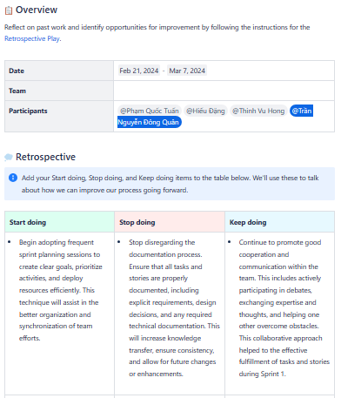

Figure 20: Sprint 1 Retrospective

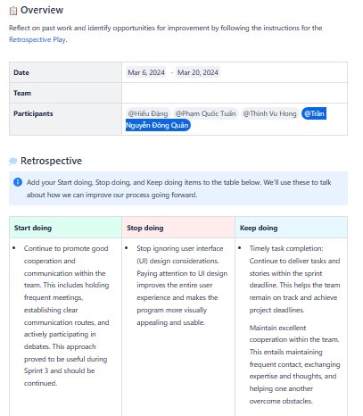

Figure 21: Sprint 2 Retrospective

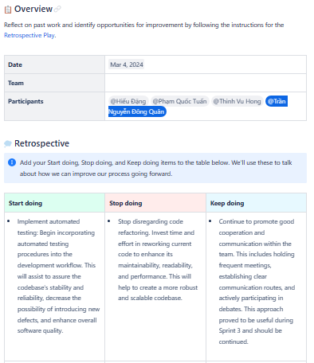

Figure 22: Sprint 3 Retrospective

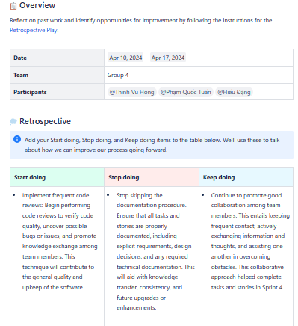

Figure 23: Sprint 4 Retrospective

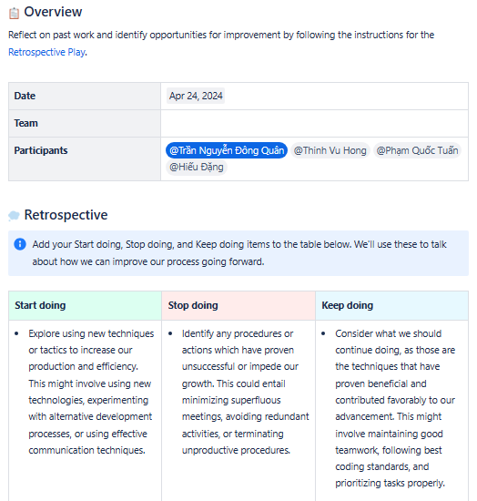

Figure 24: Sprint 5 Retrospective

### Burn down Chart.

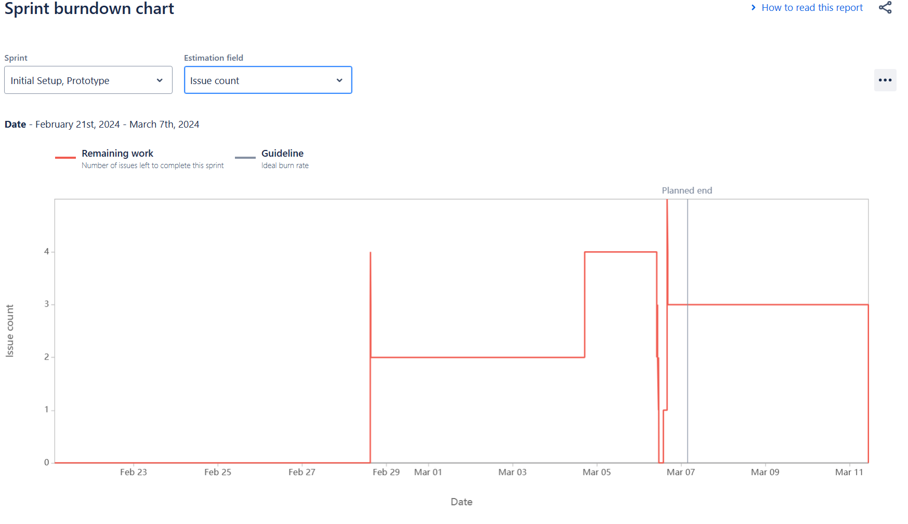

Figure 25: Sprint 1 Burndown Chart

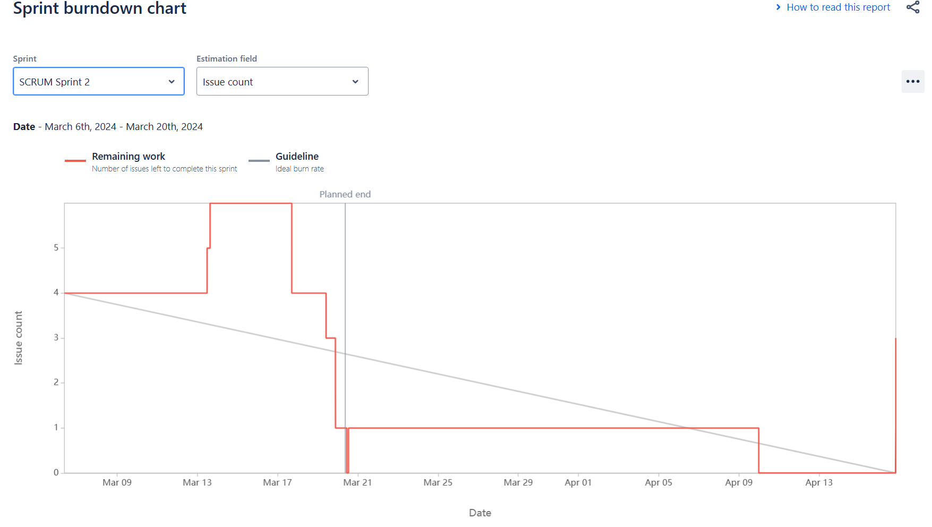

Figure 26: Sprint 2 Burndown chart

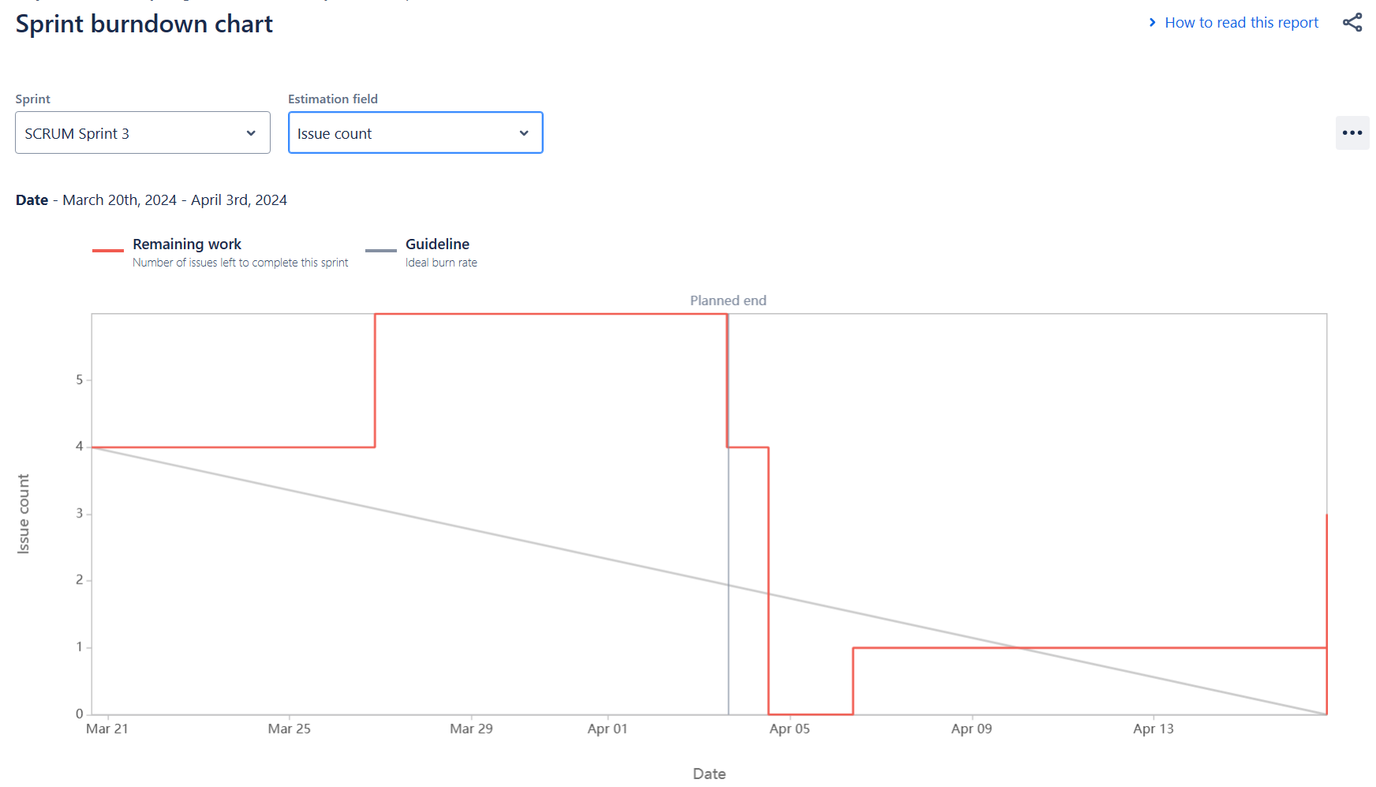

Figure 27: Sprint 3 Burndown Chart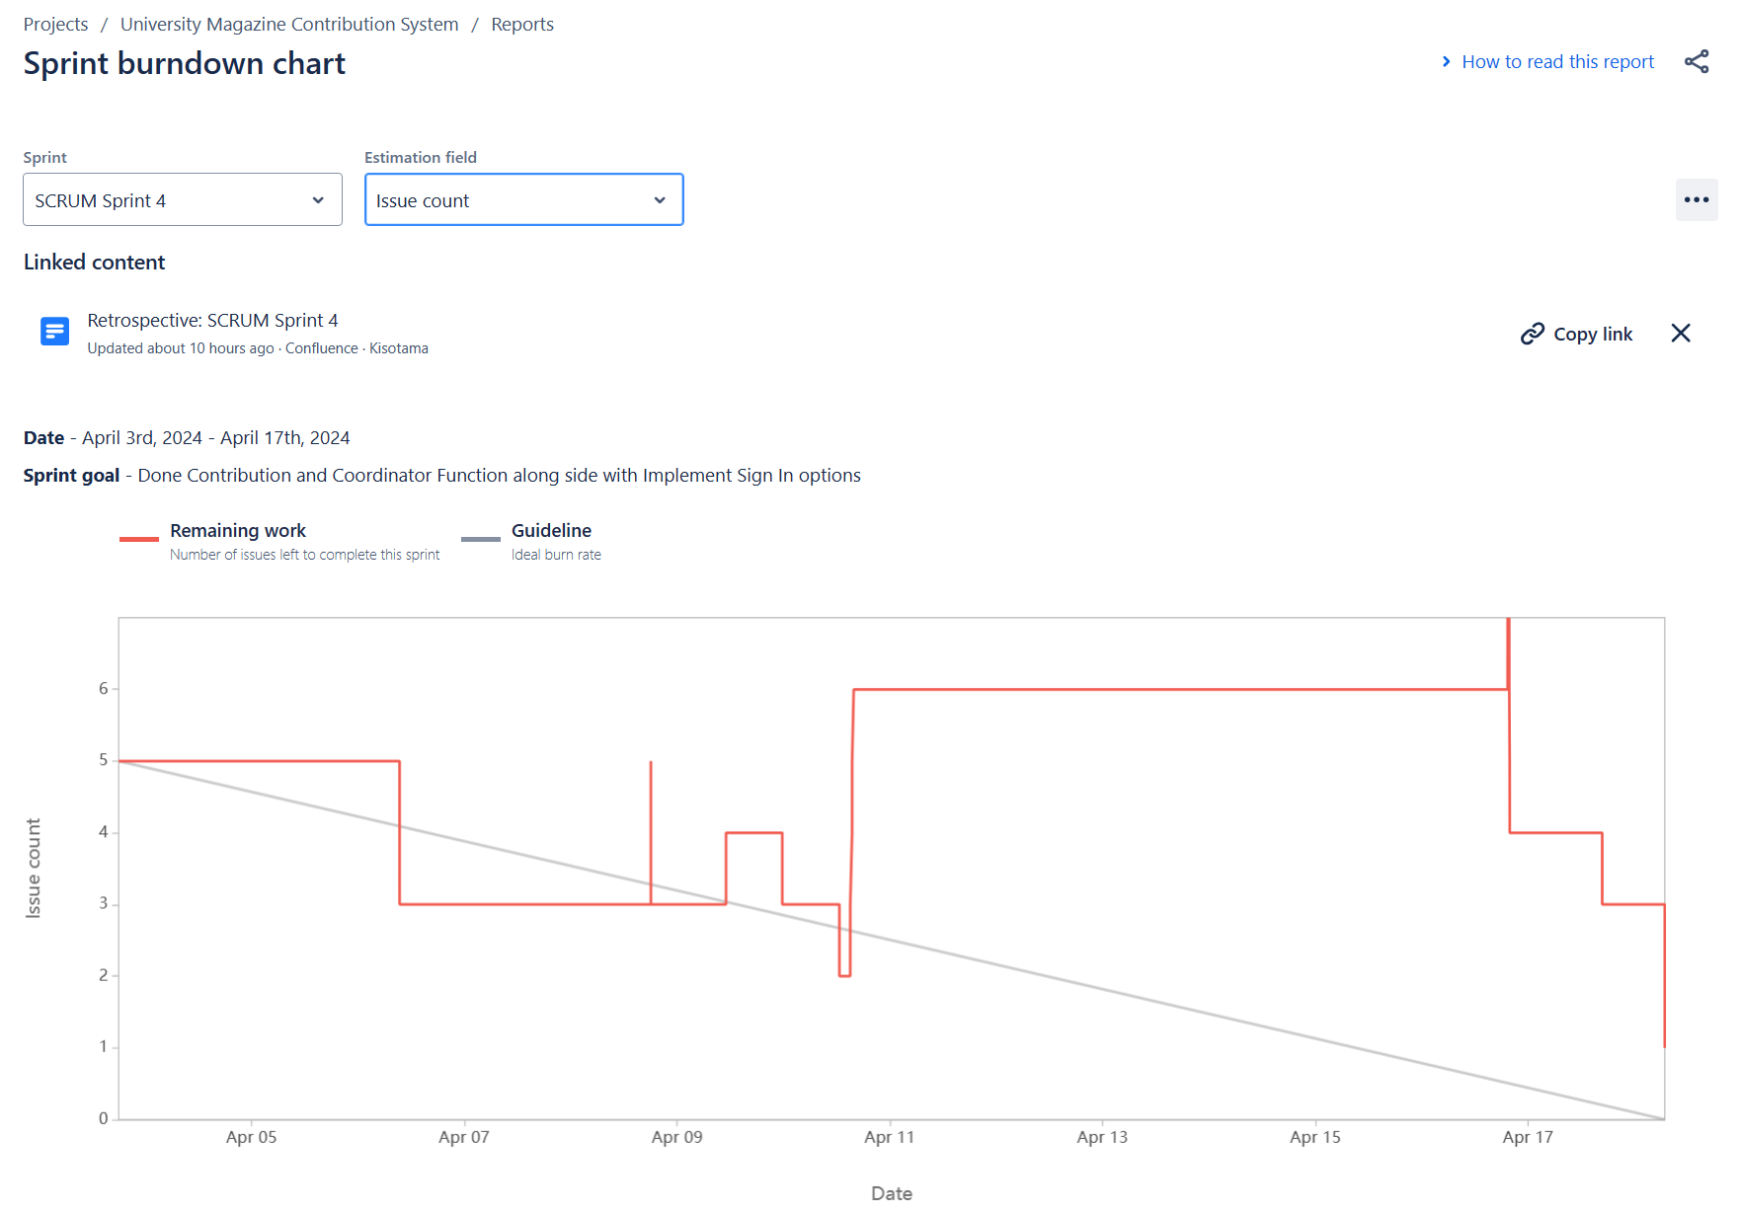

Figure 28: Sprint 4 Burndown Chart

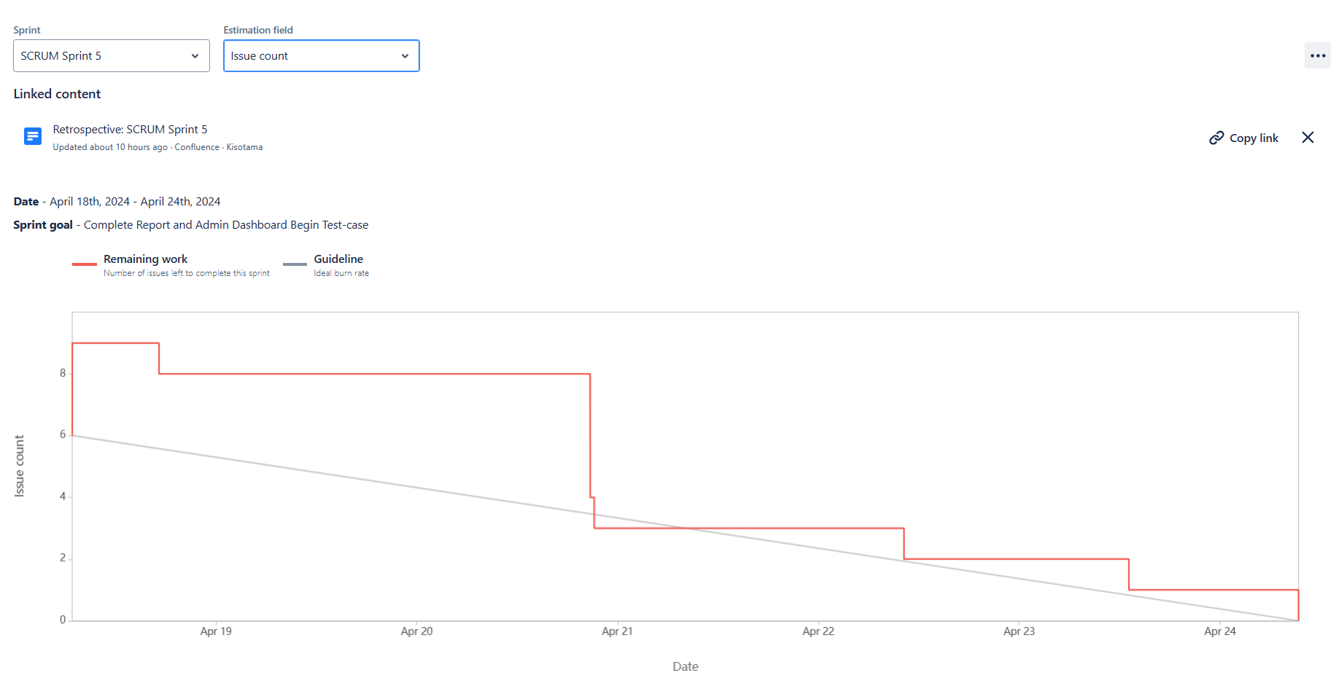

Figure 29: Sprint 5 Burndown Chart

# Testing:

|  |  |  |
| --- | --- | --- |
| **User Test Case** | **Input** | **Expected Output** |
| GetUserByUsernameAndPassword | Gcs210485, "dualshock4" | Returns the user object with the provided username and password if found in the database. Otherwise, returns null. |
| GetByIdAsync | Gcs210485 | Returns the user object with the provided login name if found in the database. Otherwise, returns null. |
| GetUsersAsync | - | Returns a list of all user objects from the database. If no users are found, returns an empty list. |
| AddUserAsync | User object with valid properties, and a valid faculty ID | Adds the user to the database and returns the added user object. Also, creates a new User_Faculty object if the user has the role of 1 or 2. If the user has the role of 3, creates a new user with null faculty ID and adds the User_Faculty objects. |
| UpdateAsync | User object with updated properties | Updates the user object in the database with the provided user object's properties. |

|  |  |  |
| --- | --- | --- |
| **SystemParameter Test-Case** | **Input** | **OutPut** |
| Get_Parameter | - | Returns the system parameter object with the name "SUBMIT_DATE" from the database. |
| check_SubmitDate | - | If the current date is before or equal to the submit due date retrieved from the "SUBMIT_DATE" system parameter, returns 0. If the current date is after the submit due date, returns 1. |
| check_CompleteDate | - | if the current date is before or equal to the complete due date retrieved from the "COMPLETE_DATE" system parameter, returns 0. If the current date is after the complete due date, returns 1. |
| Dashboard | - | Returns a dictionary with the following key-value pairs: "TotalContributions" (total number of contributions in the database) and "NumOfC_[FacultyName]" (number of contributions for each faculty in the database). |
| SendEmail | _sender: valid sender email address, _receiver: valid receiver email address, title: string, content: string | Returns 0 if the email is sent successfully |
| GetReportData | - | Returns a list of ReportData objects containing aggregated data for each faculty, year, total contributions, total students, and percentage contributions in the database. |
| GetContributionsWithoutCommentsReport | - | Returns a list of ReportDataWithoutComment objects containing contributions without comments that are older than 14 days, along with associated faculty, contributor name, and title. |

|  |  |  |
| --- | --- | --- |
| **Faculty test-case** | **Input** | **Out-put** |
| GetByIdAsync | string id | Returns the Faculty object with the given id from the database. |
| GetFacultyAsync | - | Returns a list of all Faculty objects from the database. |
| GetAllContributionAsync | string id | Returns a list of Contribution objects associated with the Faculty with the given id, including their related Student and Comment objects. |
| GetAllStudentAsync | - | Returns a list of all Student objects from the database. |

|  |  |  |
| --- | --- | --- |
| **Contribution Test-case** | **Input** | **Output** |
| AddContributionAsync | id: string, title: string, description: string, type: string, content: string, indexNumber: int, academy: string | Creates a new Contribution object with the given inputs and adds it to the database. Returns the added Contribution object. |
| GetByIdAsync | id: string | Returns the Contribution object with the given id from the database. |
| GetComment | id: string | Returns a list of Comment objects associated with the Contribution with the given id from the database. |
| GetAllAsync | - | Returns a list of all Contribution objects from the database. |
| UpdateAsync | id: string, title: string, description: string, type: string, content: string | Updates the Contribution object with the given id in the database with the provided inputs. Returns the updated Contribution object. |
| SetStatus | id: string, status: int | Updates the status of the Contribution object with the given id in the database to the provided status value. Returns the updated Contribution object. |
| SetExpired | - | Updates the "Expired" property of Contribution objects in the database based on the current date and a system parameter value. |
| Get_Maxnumber_ID | studentId: string | Returns the maximum "Number_Id" value among Contribution objects associated with the given studentId from the database. |
| SetComment | user_id: string, contributionId: string, title: string, comment: string | Creates a new Comment object associated with the Contribution with the given contributionId in the database. Sends an email notification and returns the added Comment object. |

# Product: Screenshots of your actual application and its functions.

## Server-Side

## Project Structure

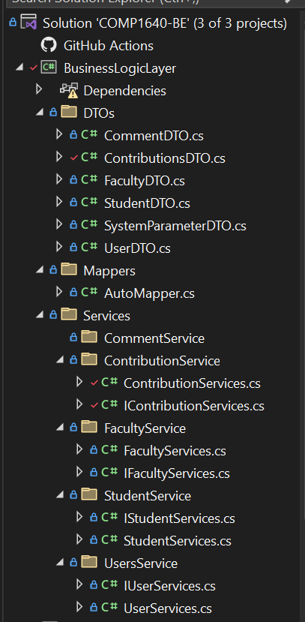

Figure 30: Project Structure.

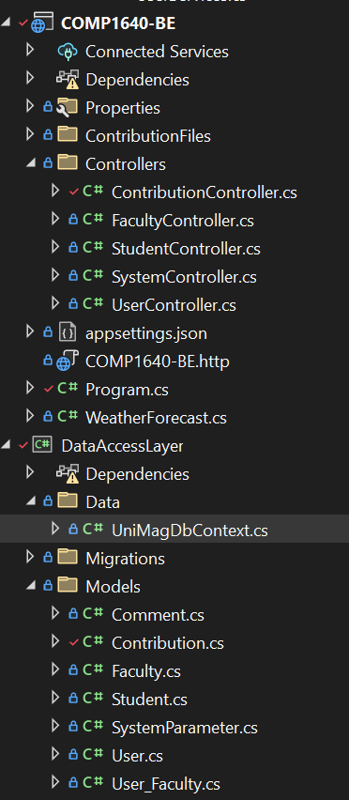

Figure 31: Project Structure.

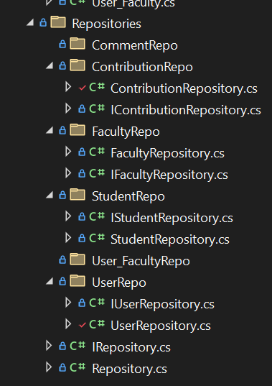

Figure 32: Project Structure

### Swagger and Function

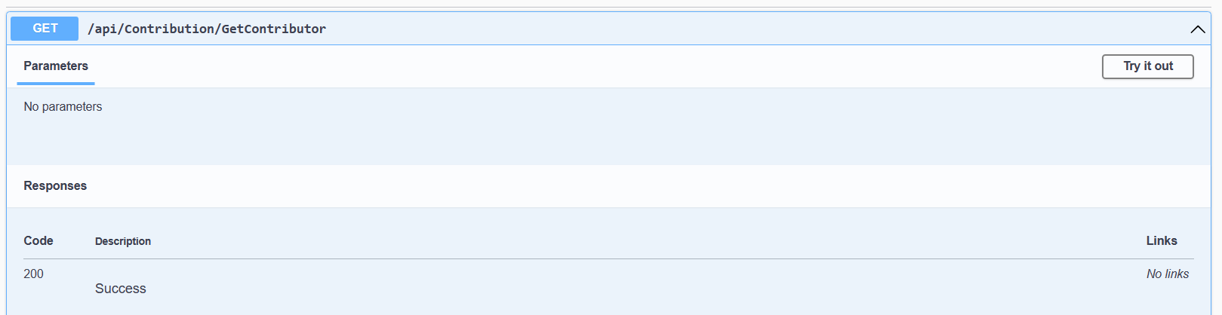

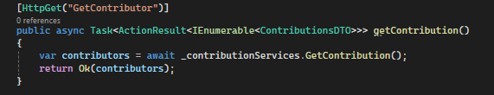

Figure 33: Get Contributior

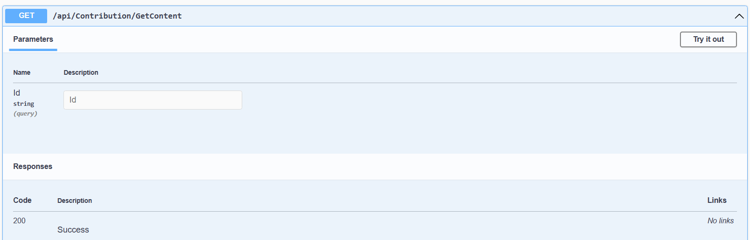

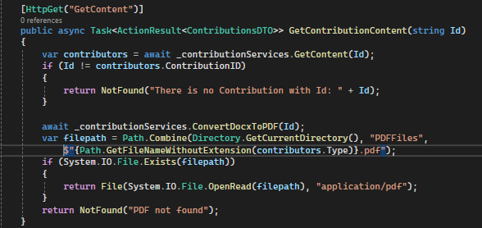

Figure 34: Get Content(read file)

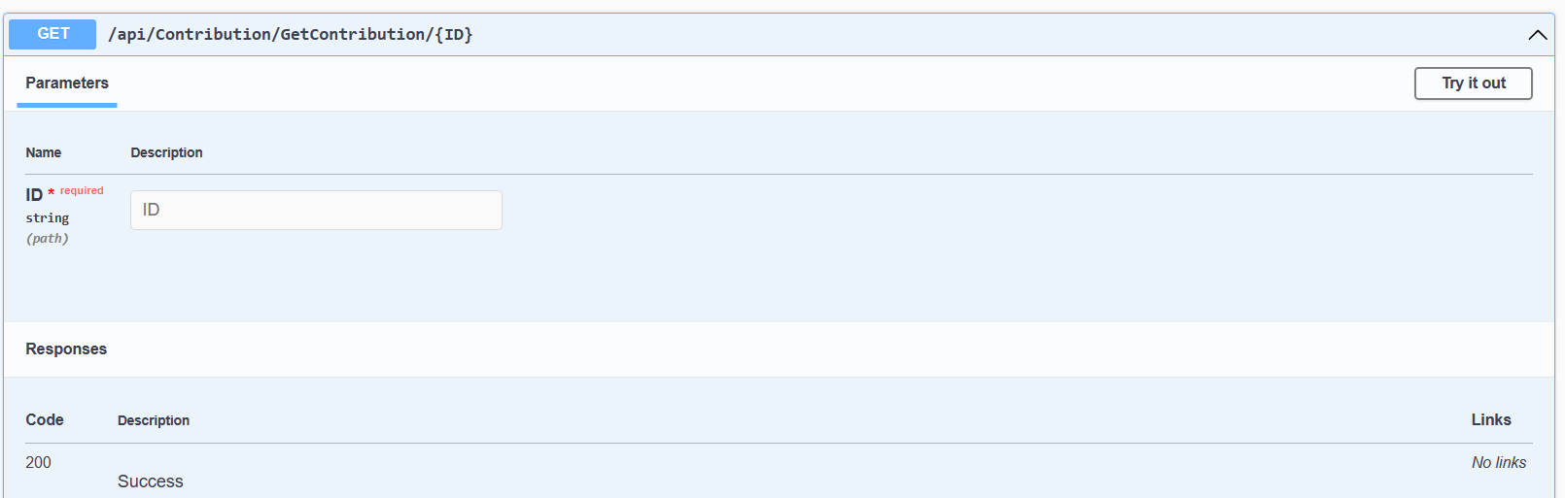

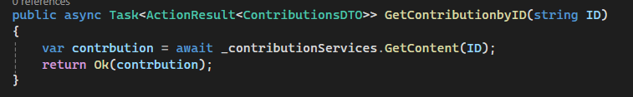

Figure 35: Get Contribution by ID

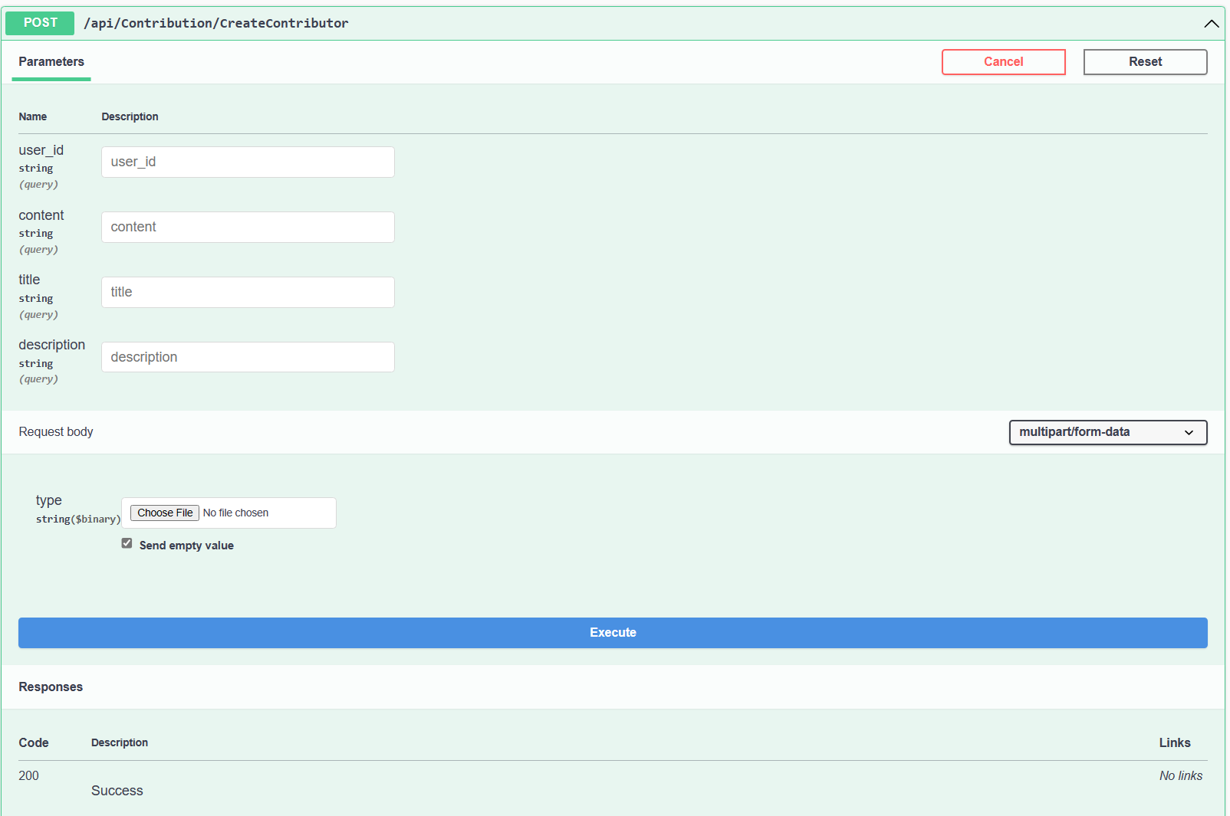

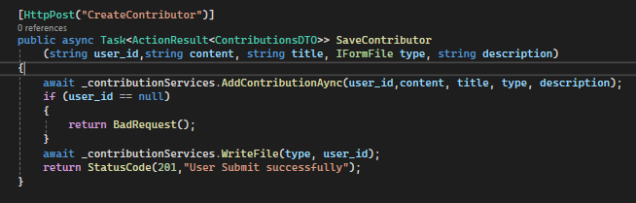

Figure 36: Create Contribution

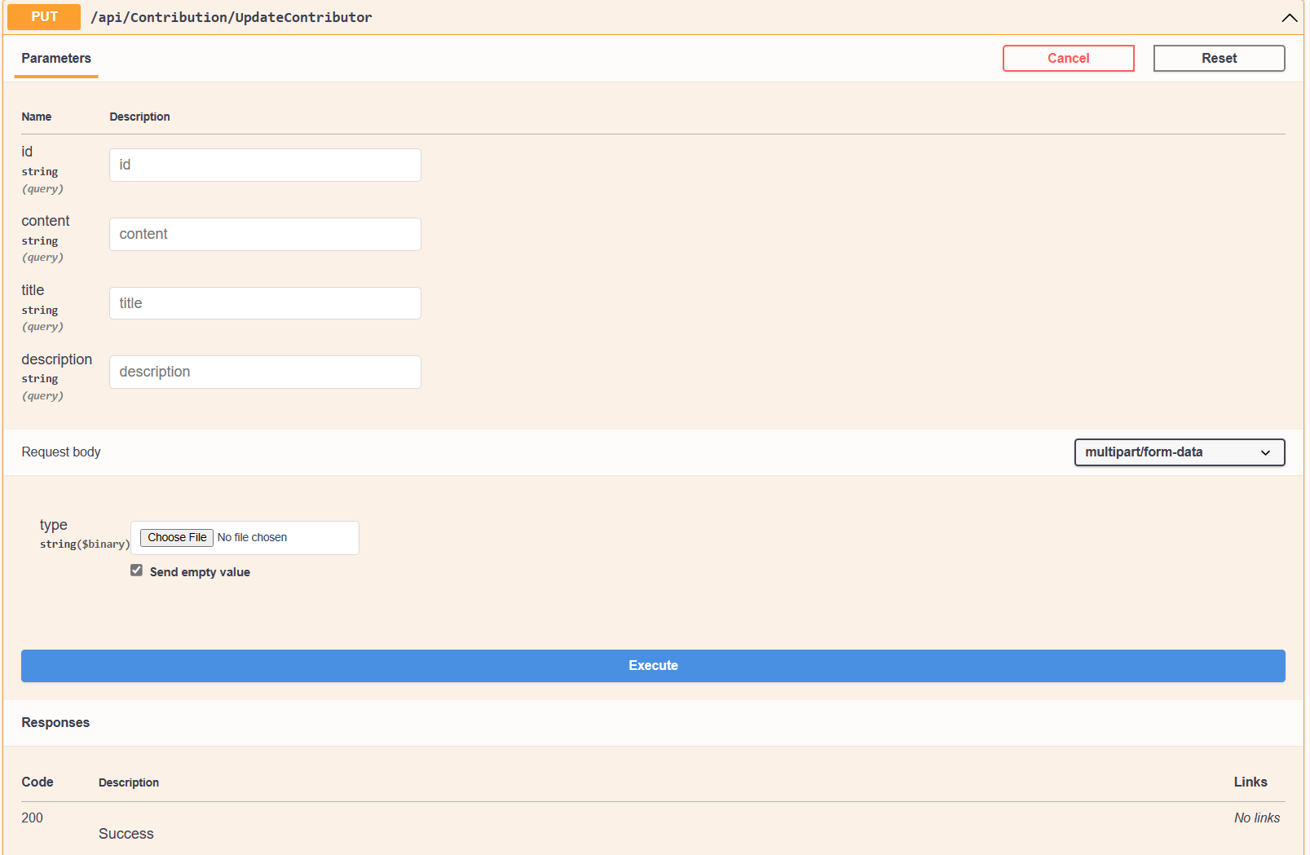

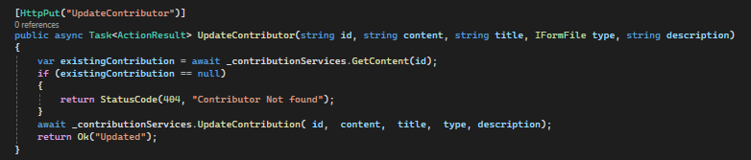

Figure 37: Update Contributor

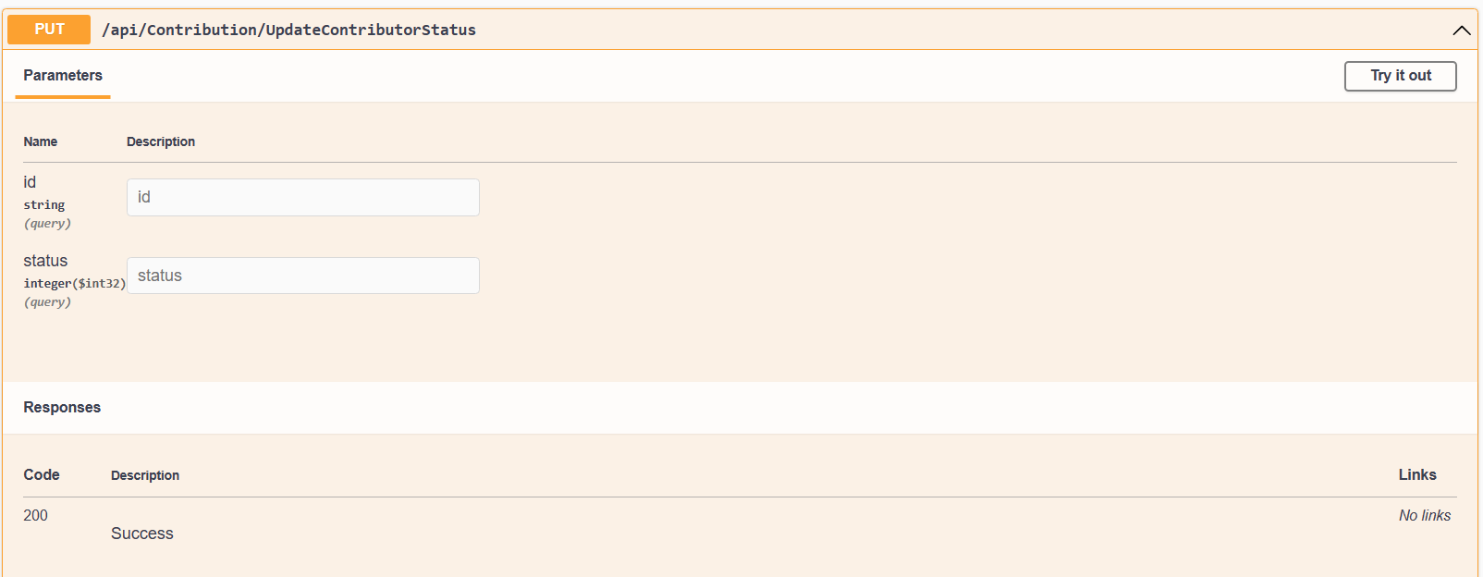

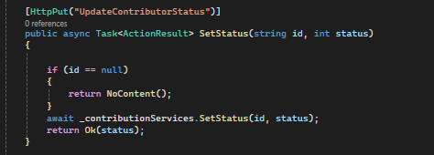

Figure 38: Update Contributor Status

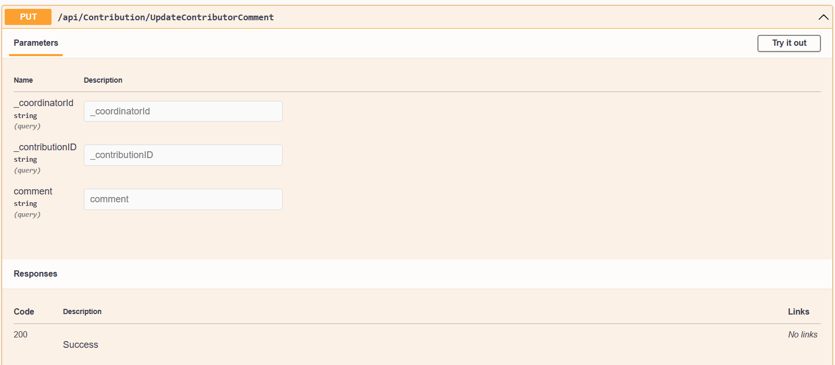

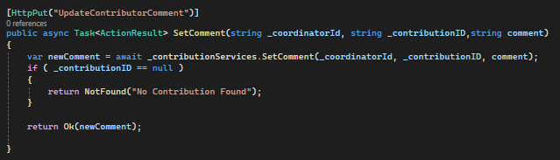

Figure 39: Update Contributor Comment

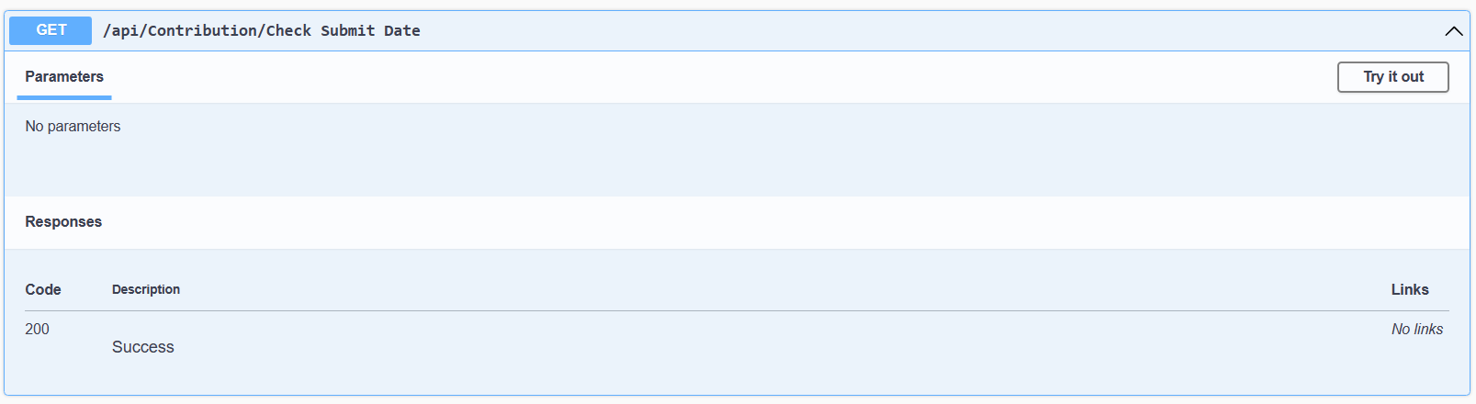

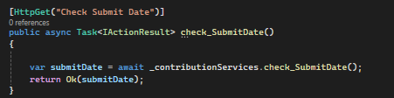

Figure 40: Check Submit Date

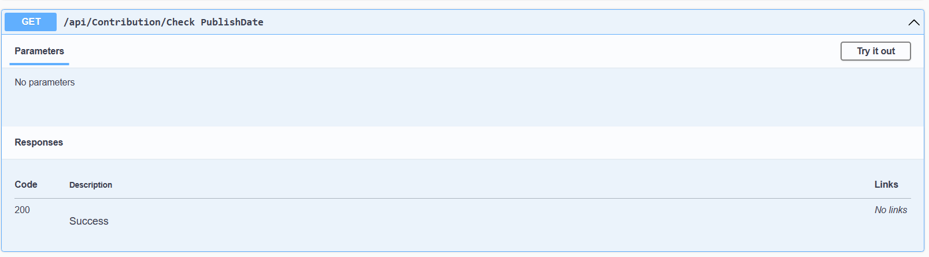

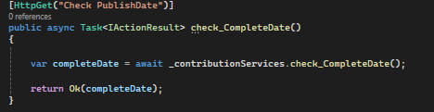

Figure 41: Check Published Date

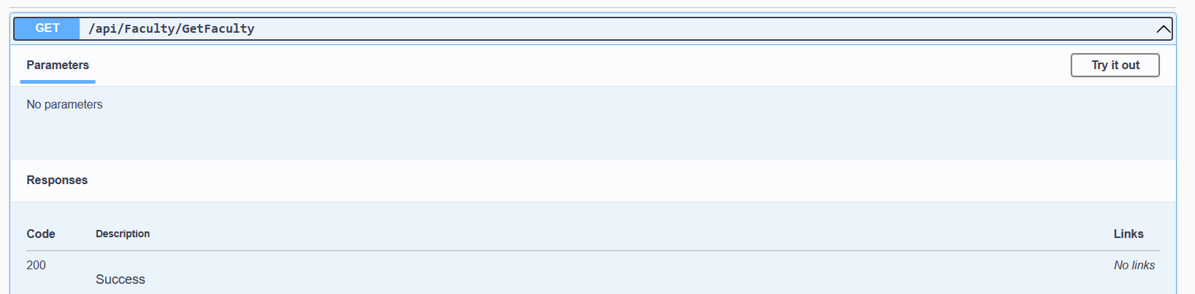

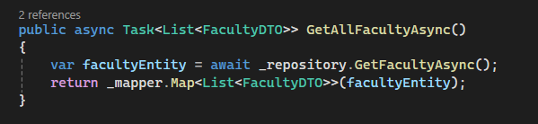

Figure 42: Get Faculty

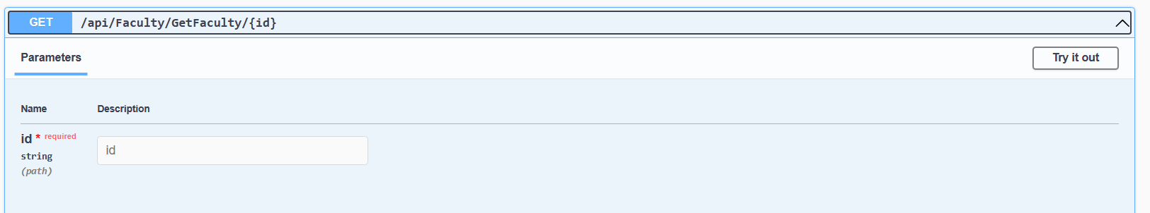

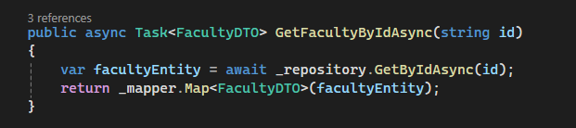

Figure 43: Get Faculty by ID

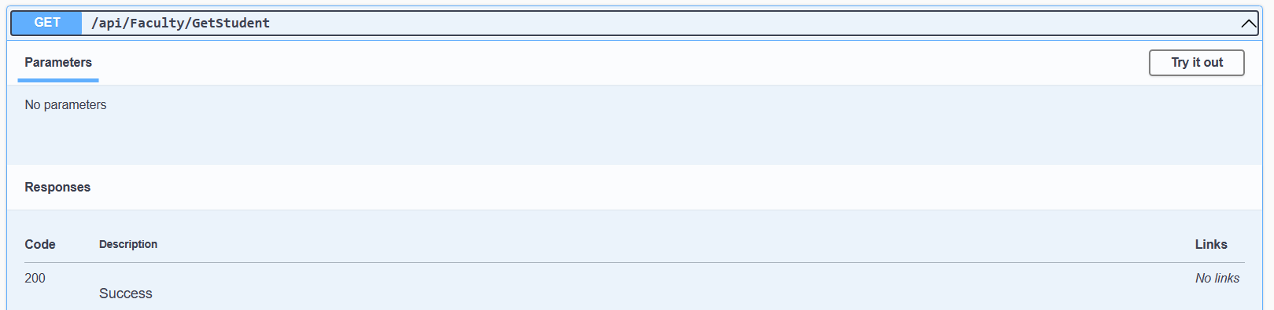

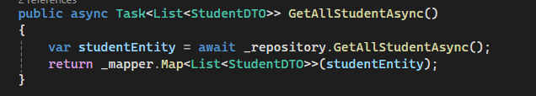

Figure 44: Get Student

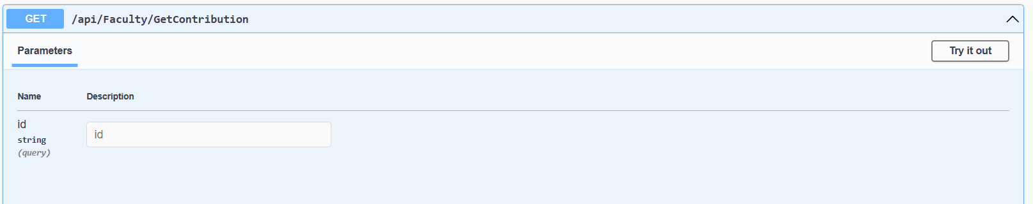

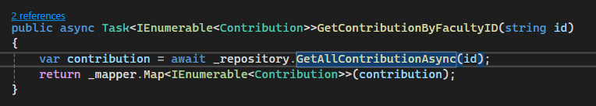

Figure 45: Get Contribution

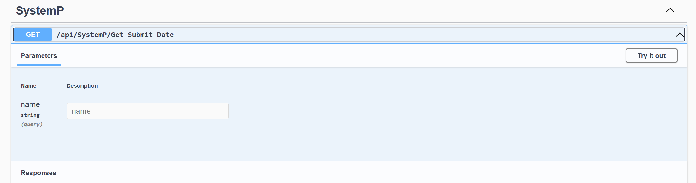

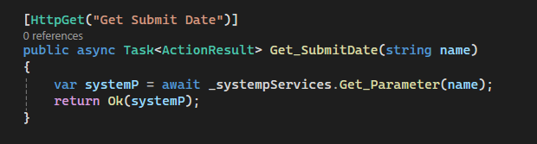

Figure 46: Get Submit Date

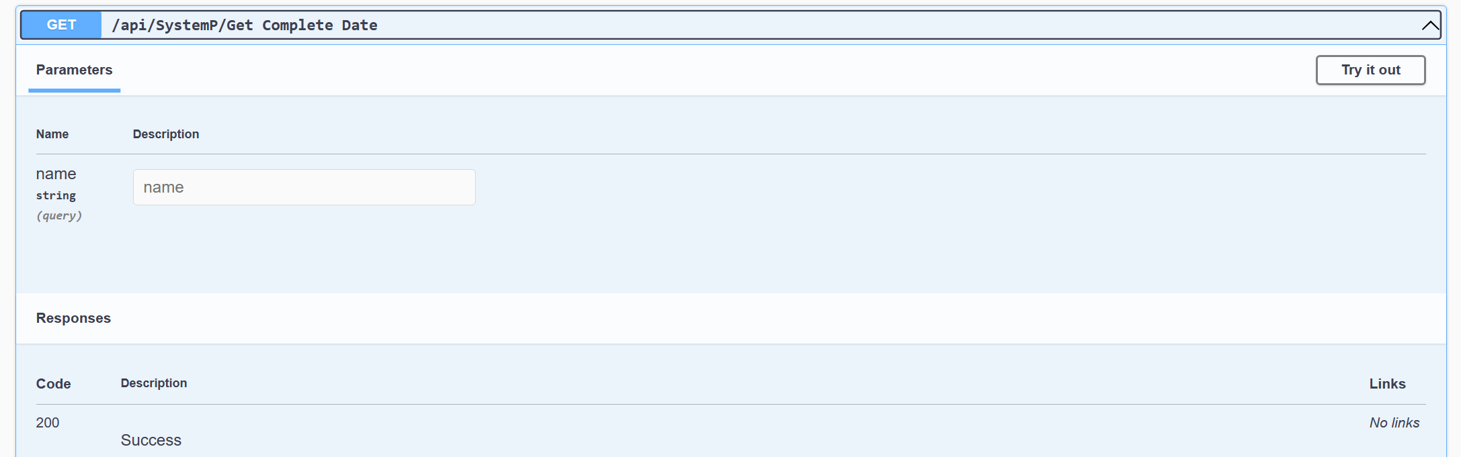

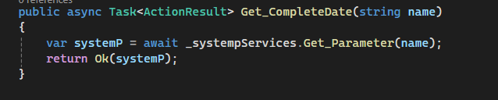

Figure 47: Get Complete Date

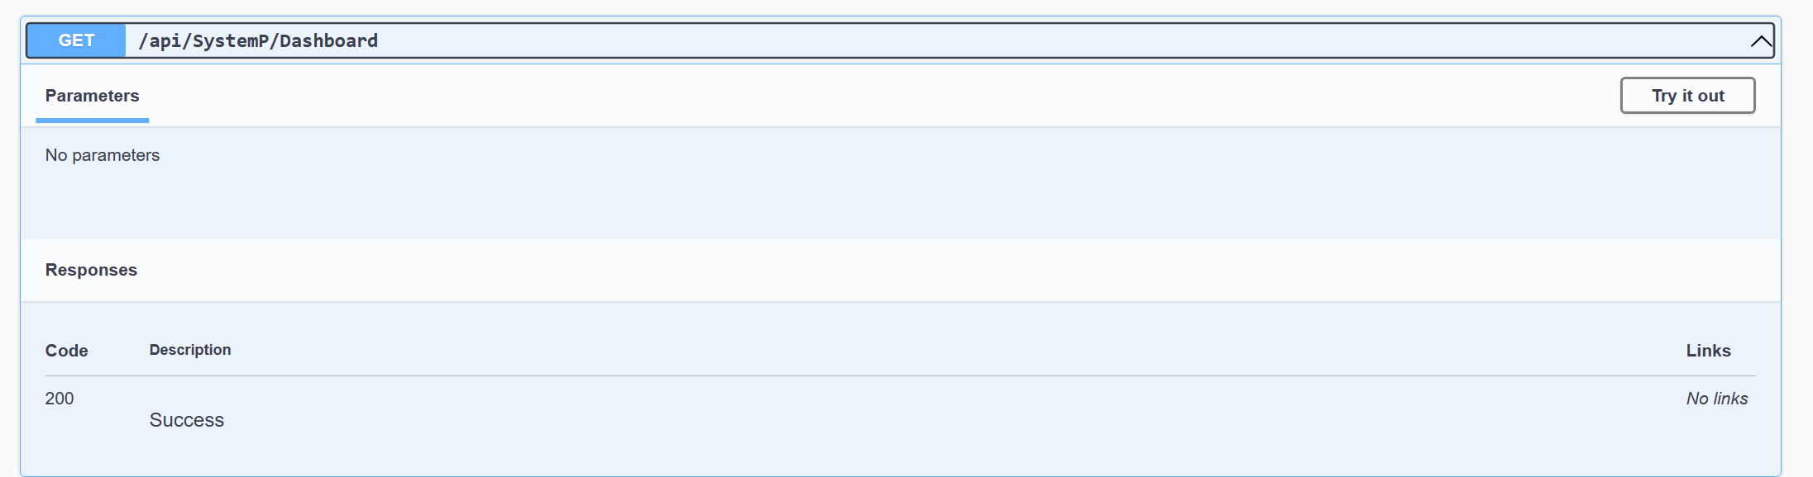

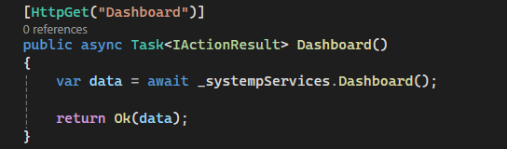

Figure 48: Dashboard

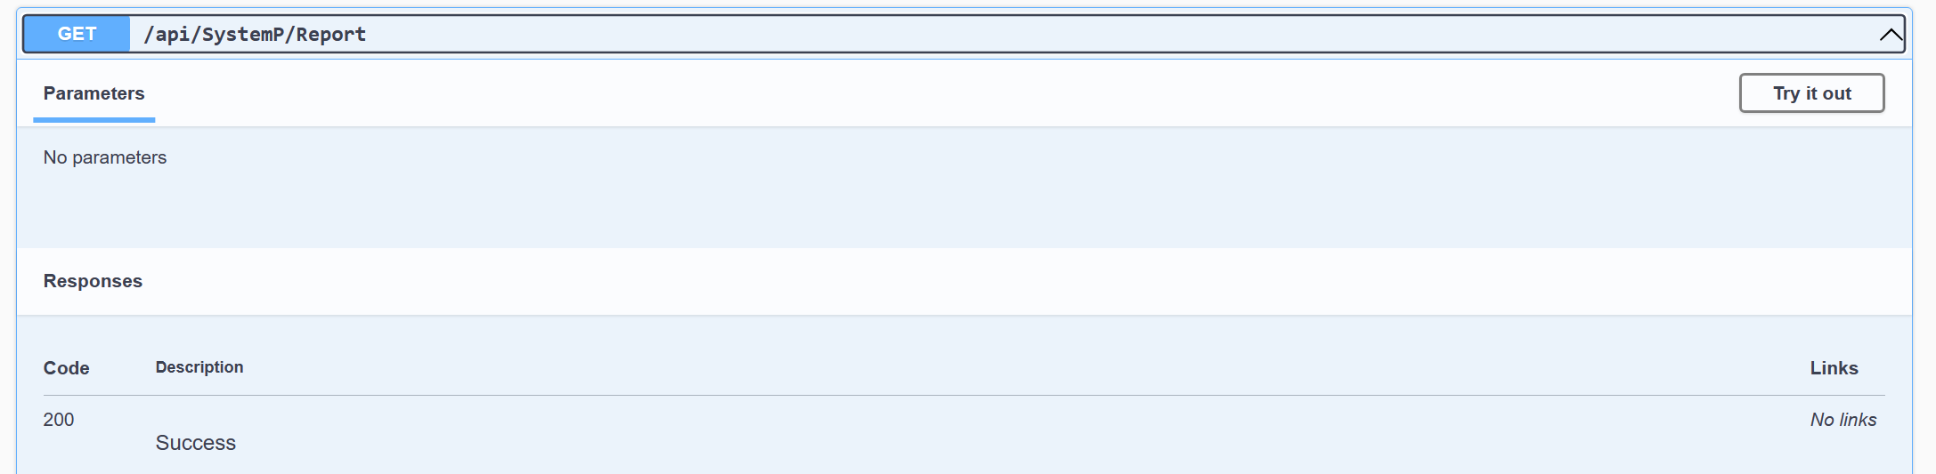

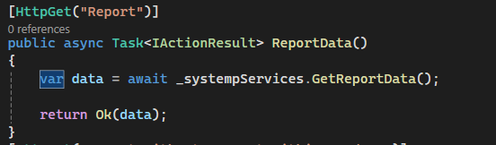

Figure 49: Get Report

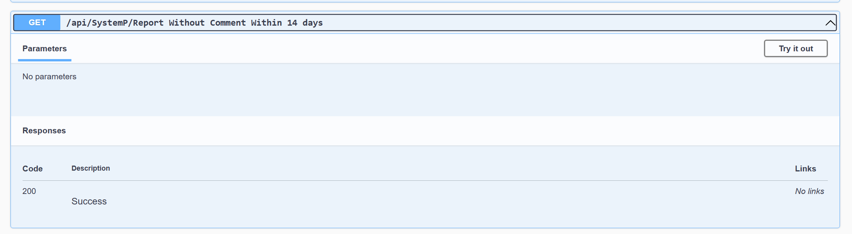

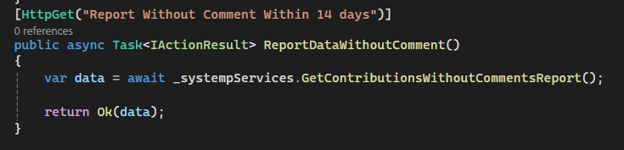

Figure 50: Get Report without comment

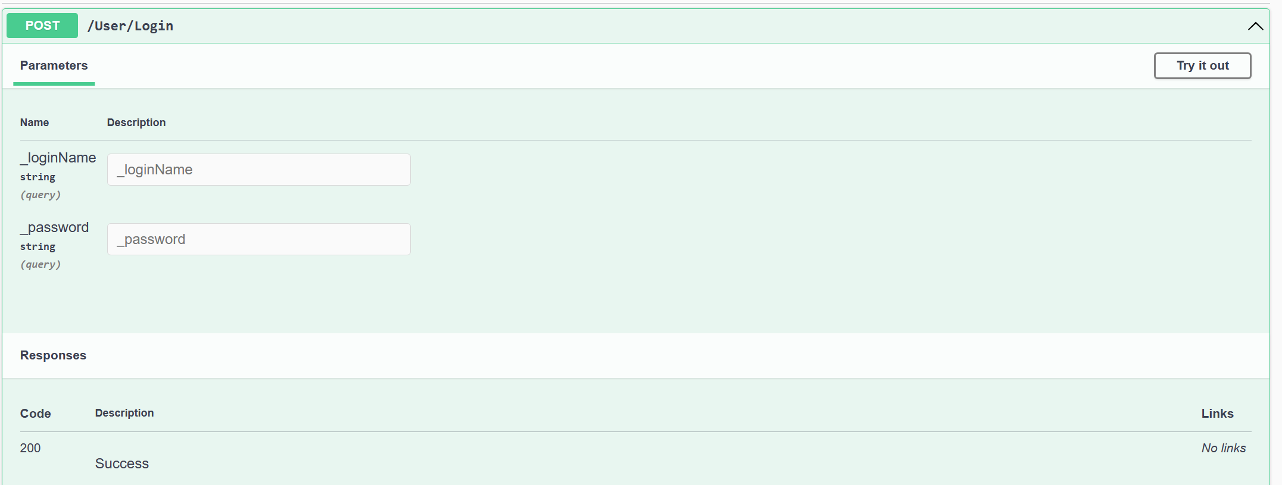

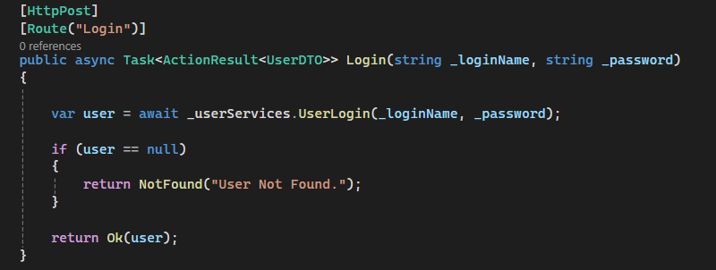

Figure 51: Login Function

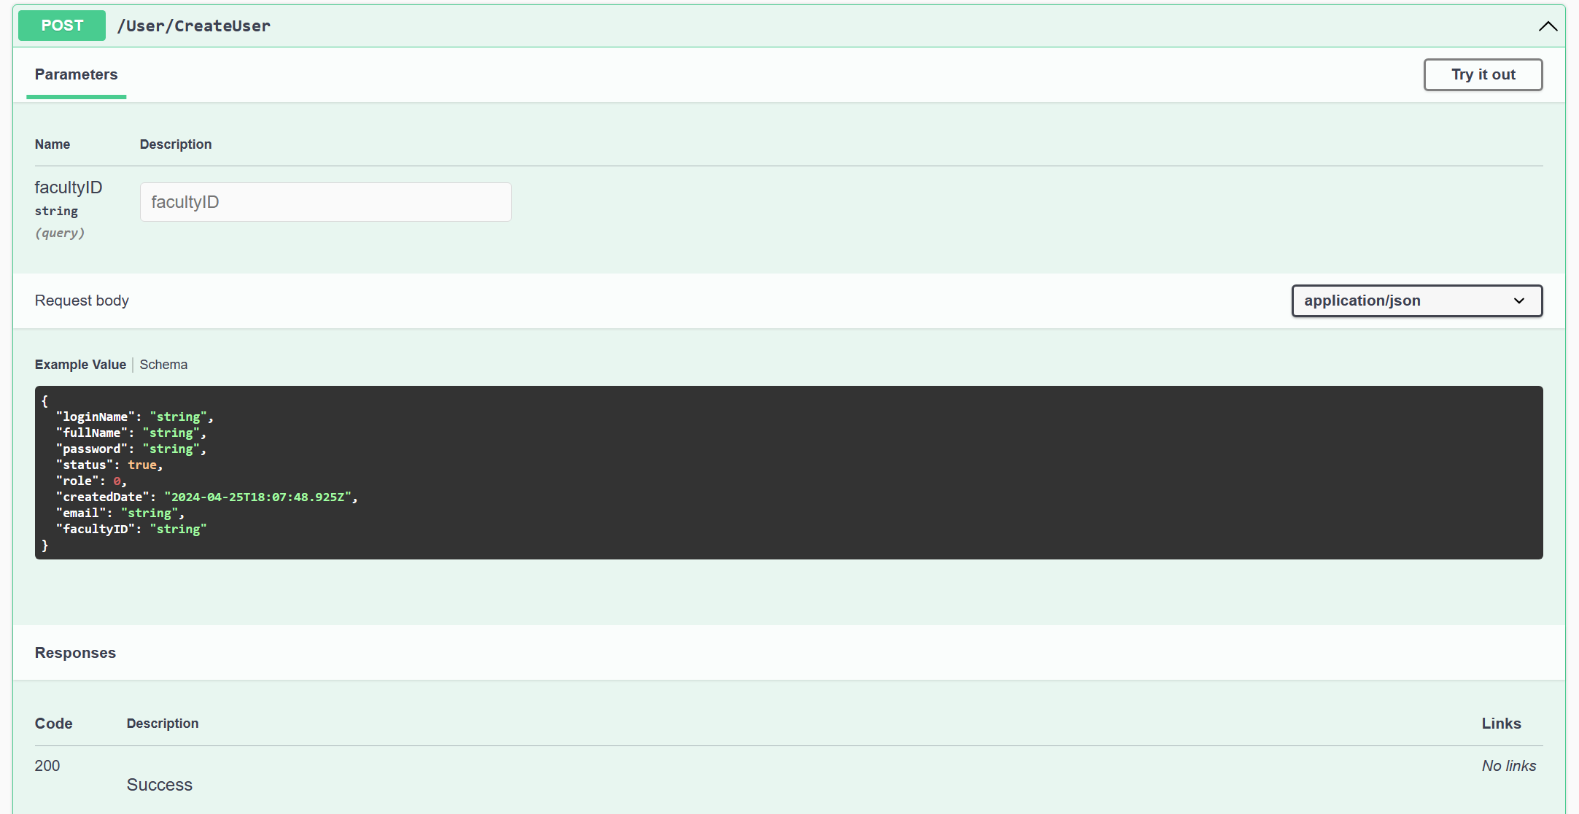

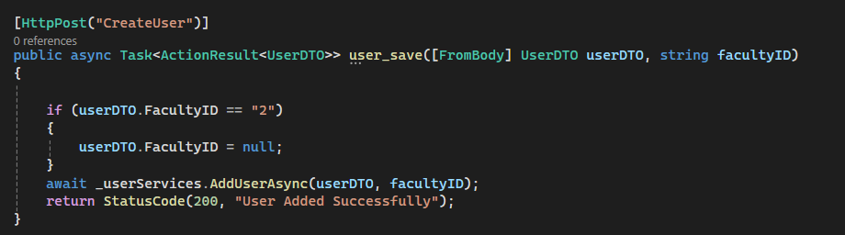

Figure 52: Create Function

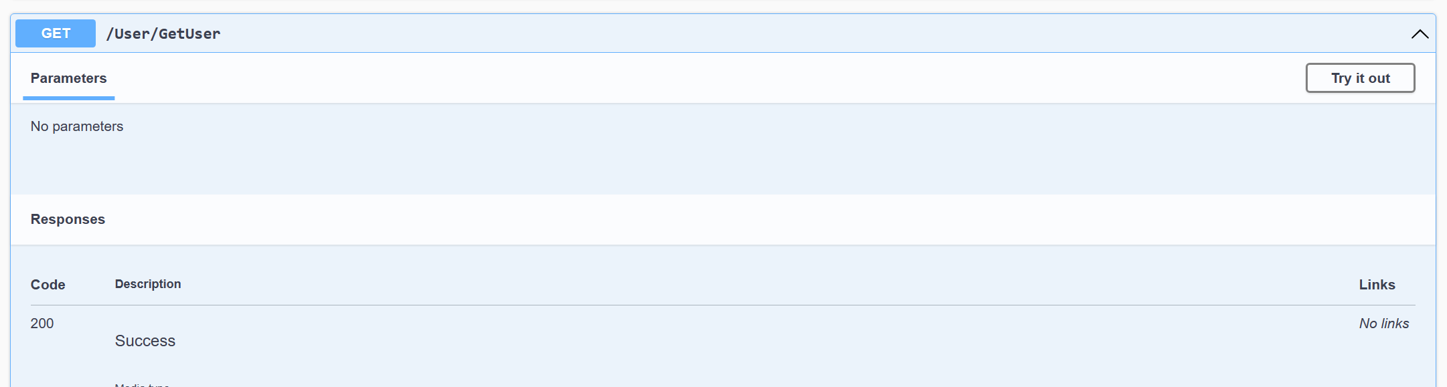

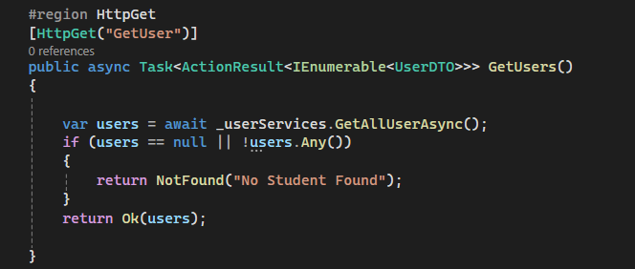

Figure 53: Get User

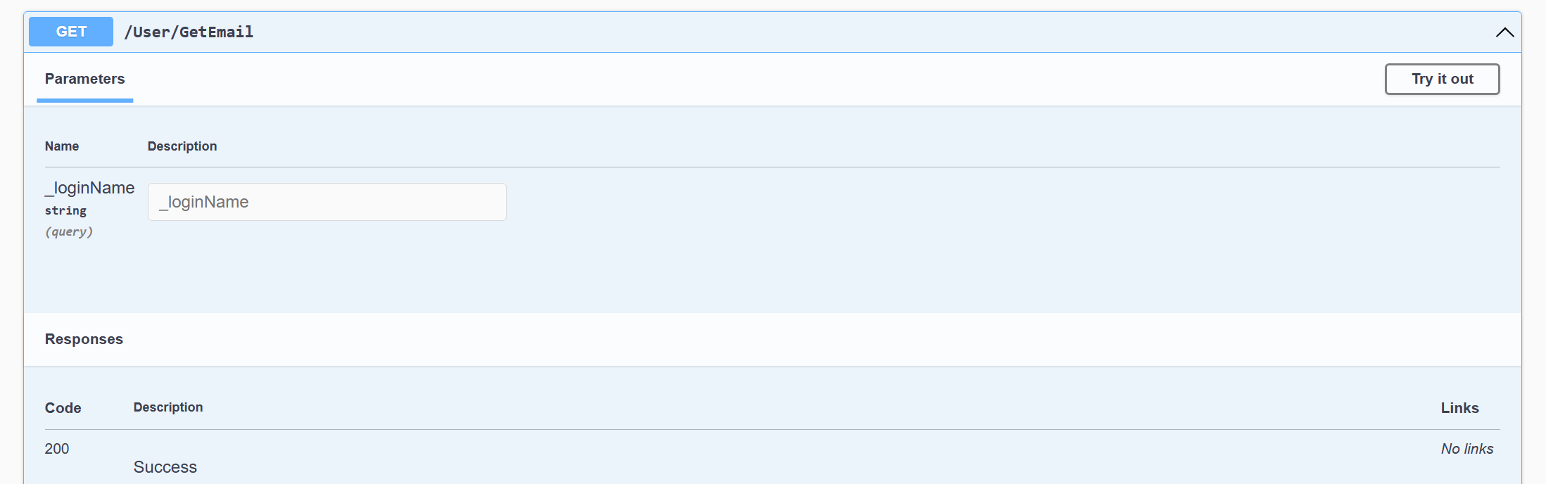

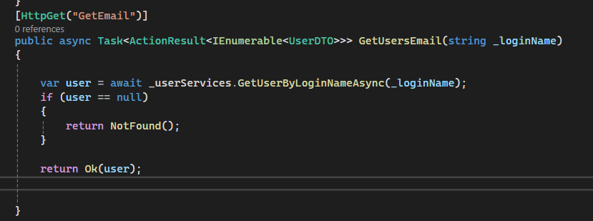

Figure 54: Get Email

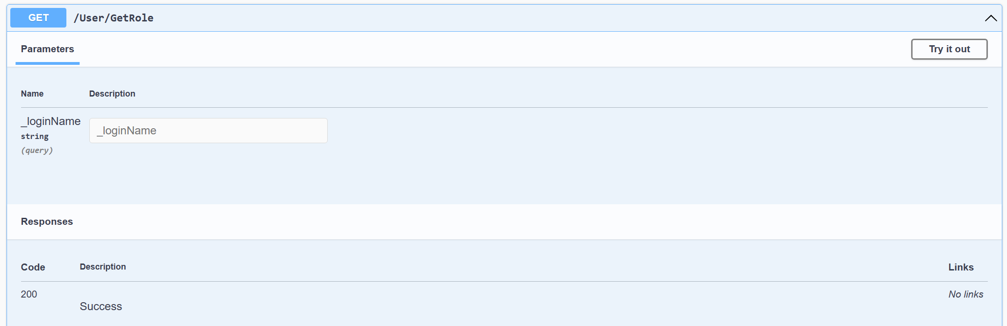

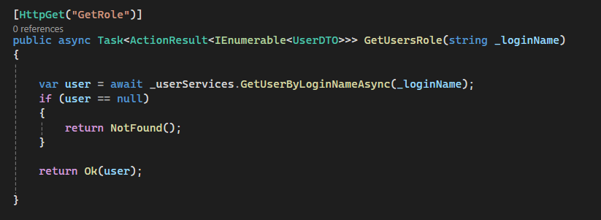

Figure 55: Get Role

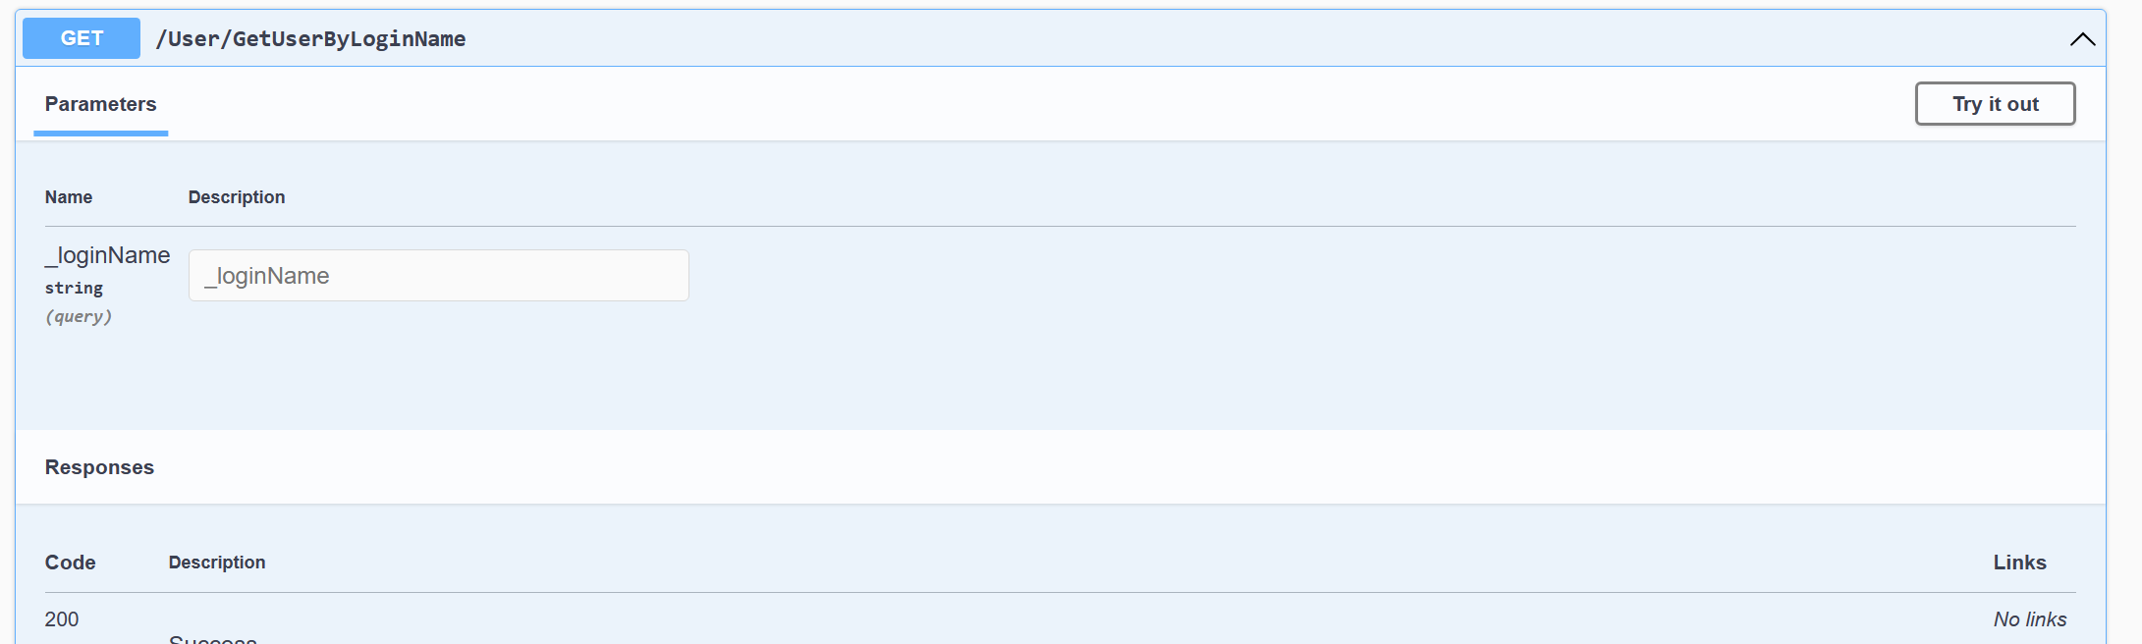

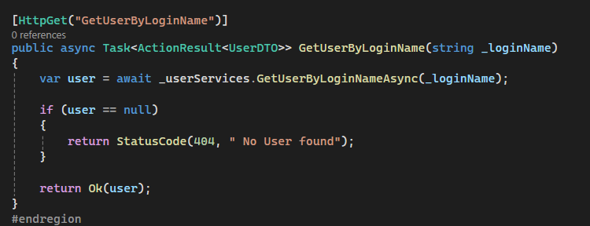

Figure 56: Get User By LoginName

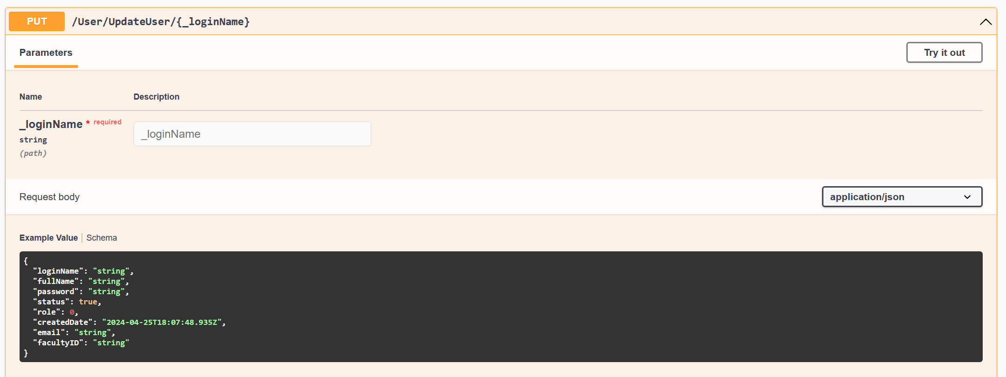

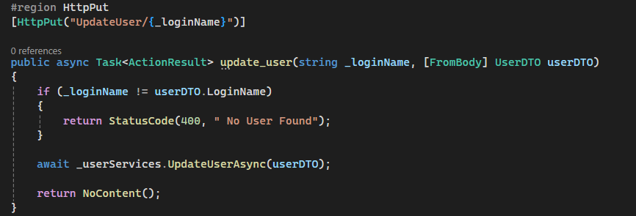

Figure 57: Update User

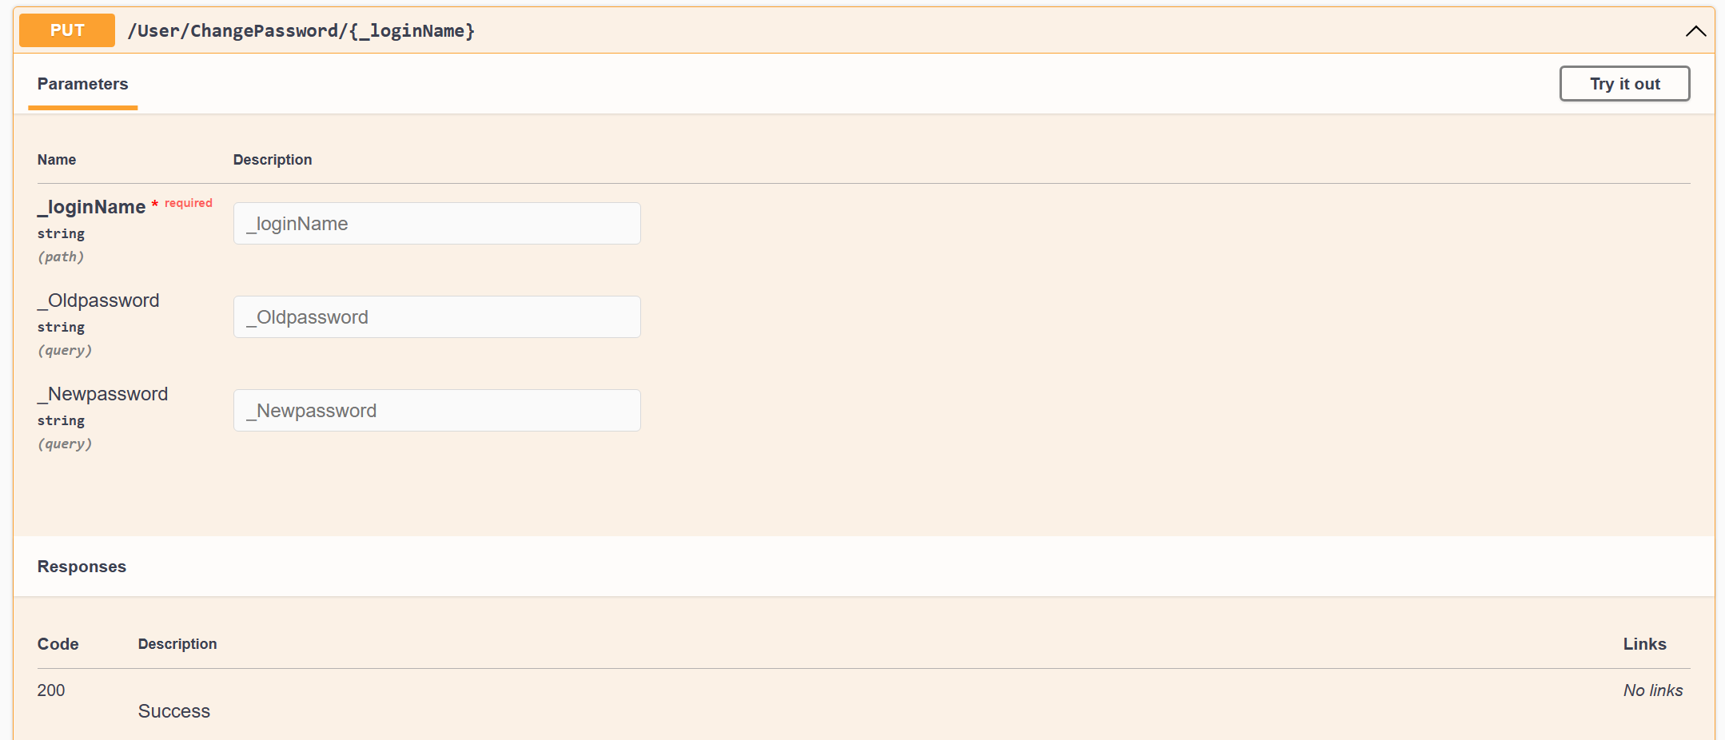

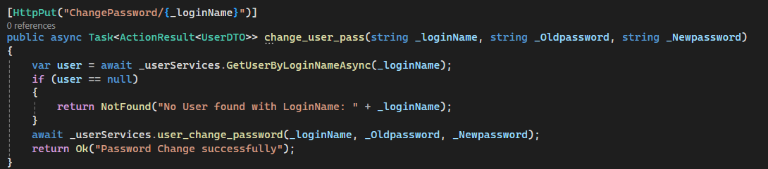

Figure 58: Change Password

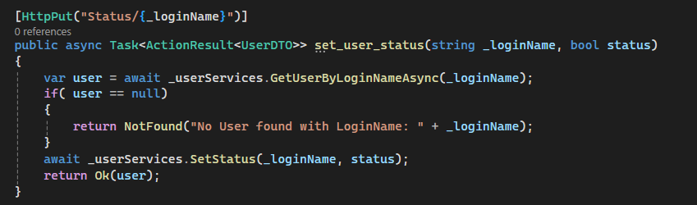

Figure 59: Update User Status

For about the connect between the back-end and frond-end, we are using typescript language and angular framework to handle this problem.   
  
Below is some picture of how to connect front-end with api.

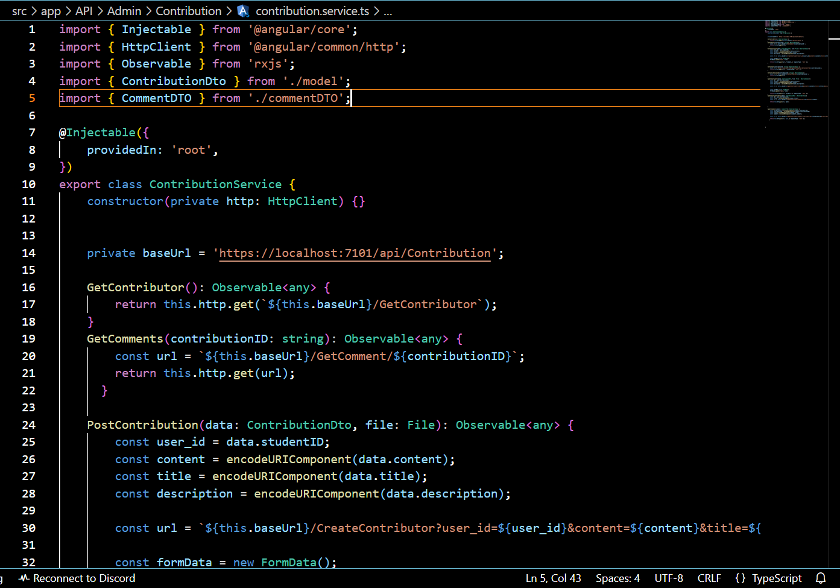

Figure 60: Contribution Service file.

This is where we call out the service from the api of Swagger and implement into the interface.

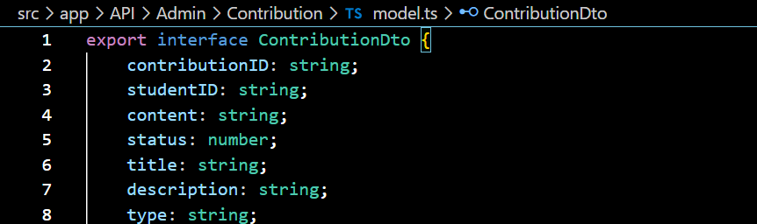

Figure 61: ContributionDTO file.

And of course we have to create the DTO of the contribution here for link data from back-end to display into the website.

All of the other service will be call like that when we implement all the function from back-end into front-end.

* Because we using 3 Tier Layer Architecture which is a little bit complicated so we can not show the full code or how to code will perform here
* For more details please visit our GitHub.

## Client-Side

6.2.1 Figma Design

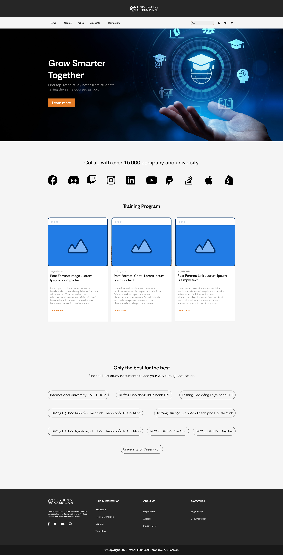

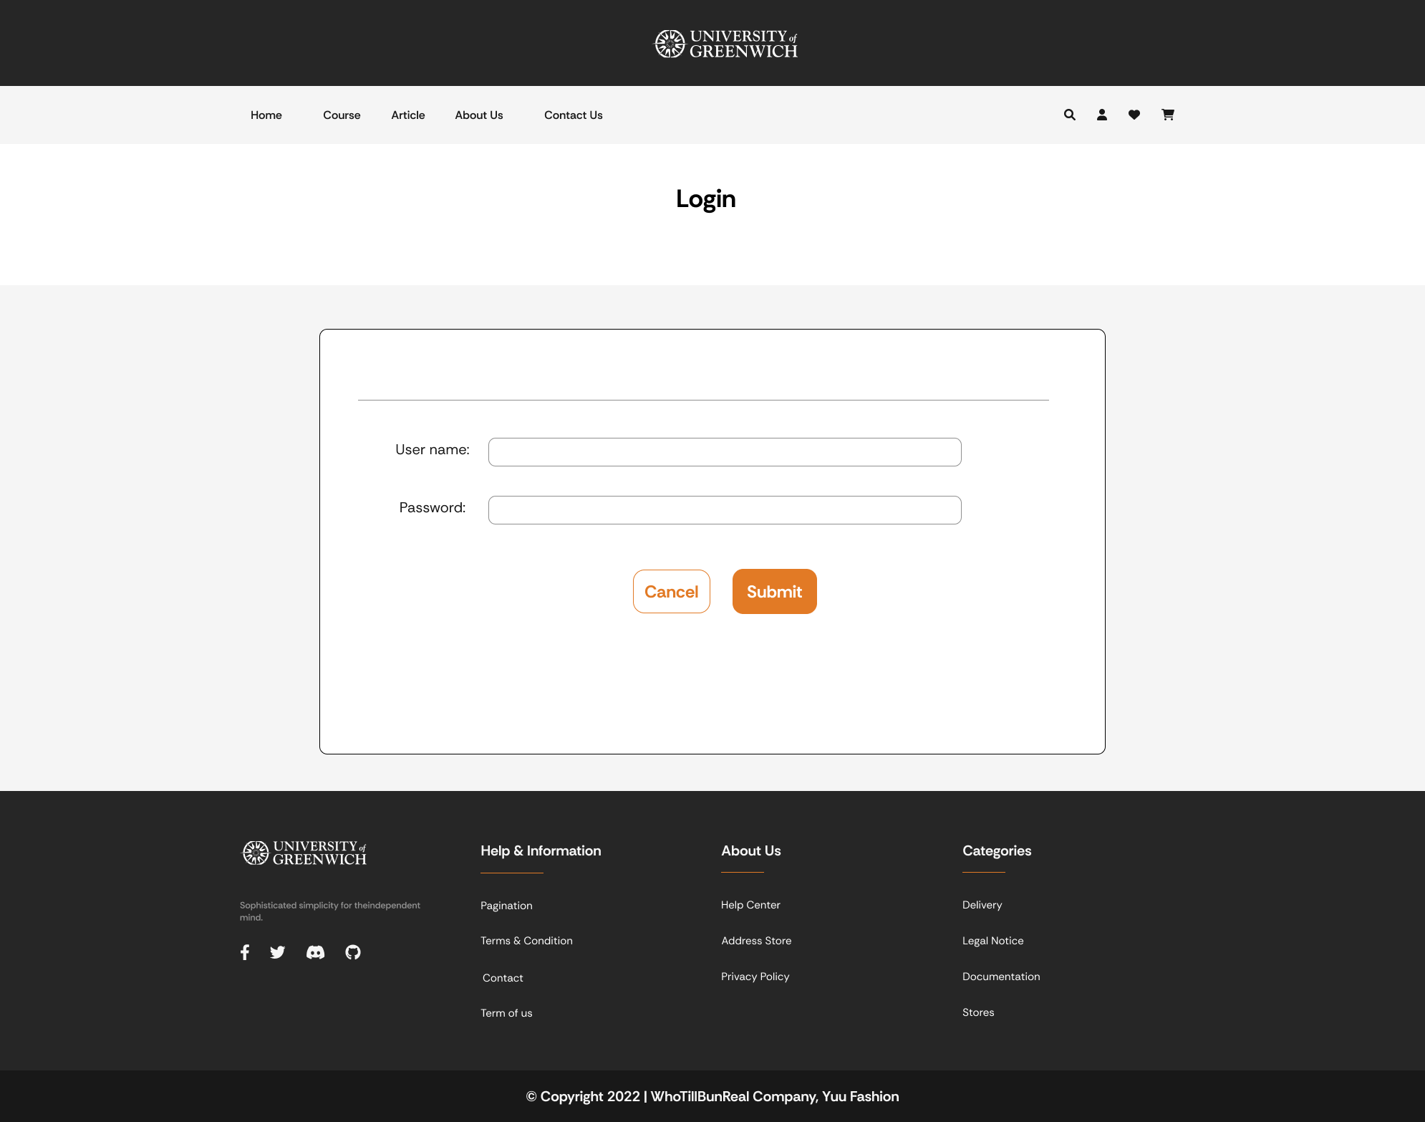

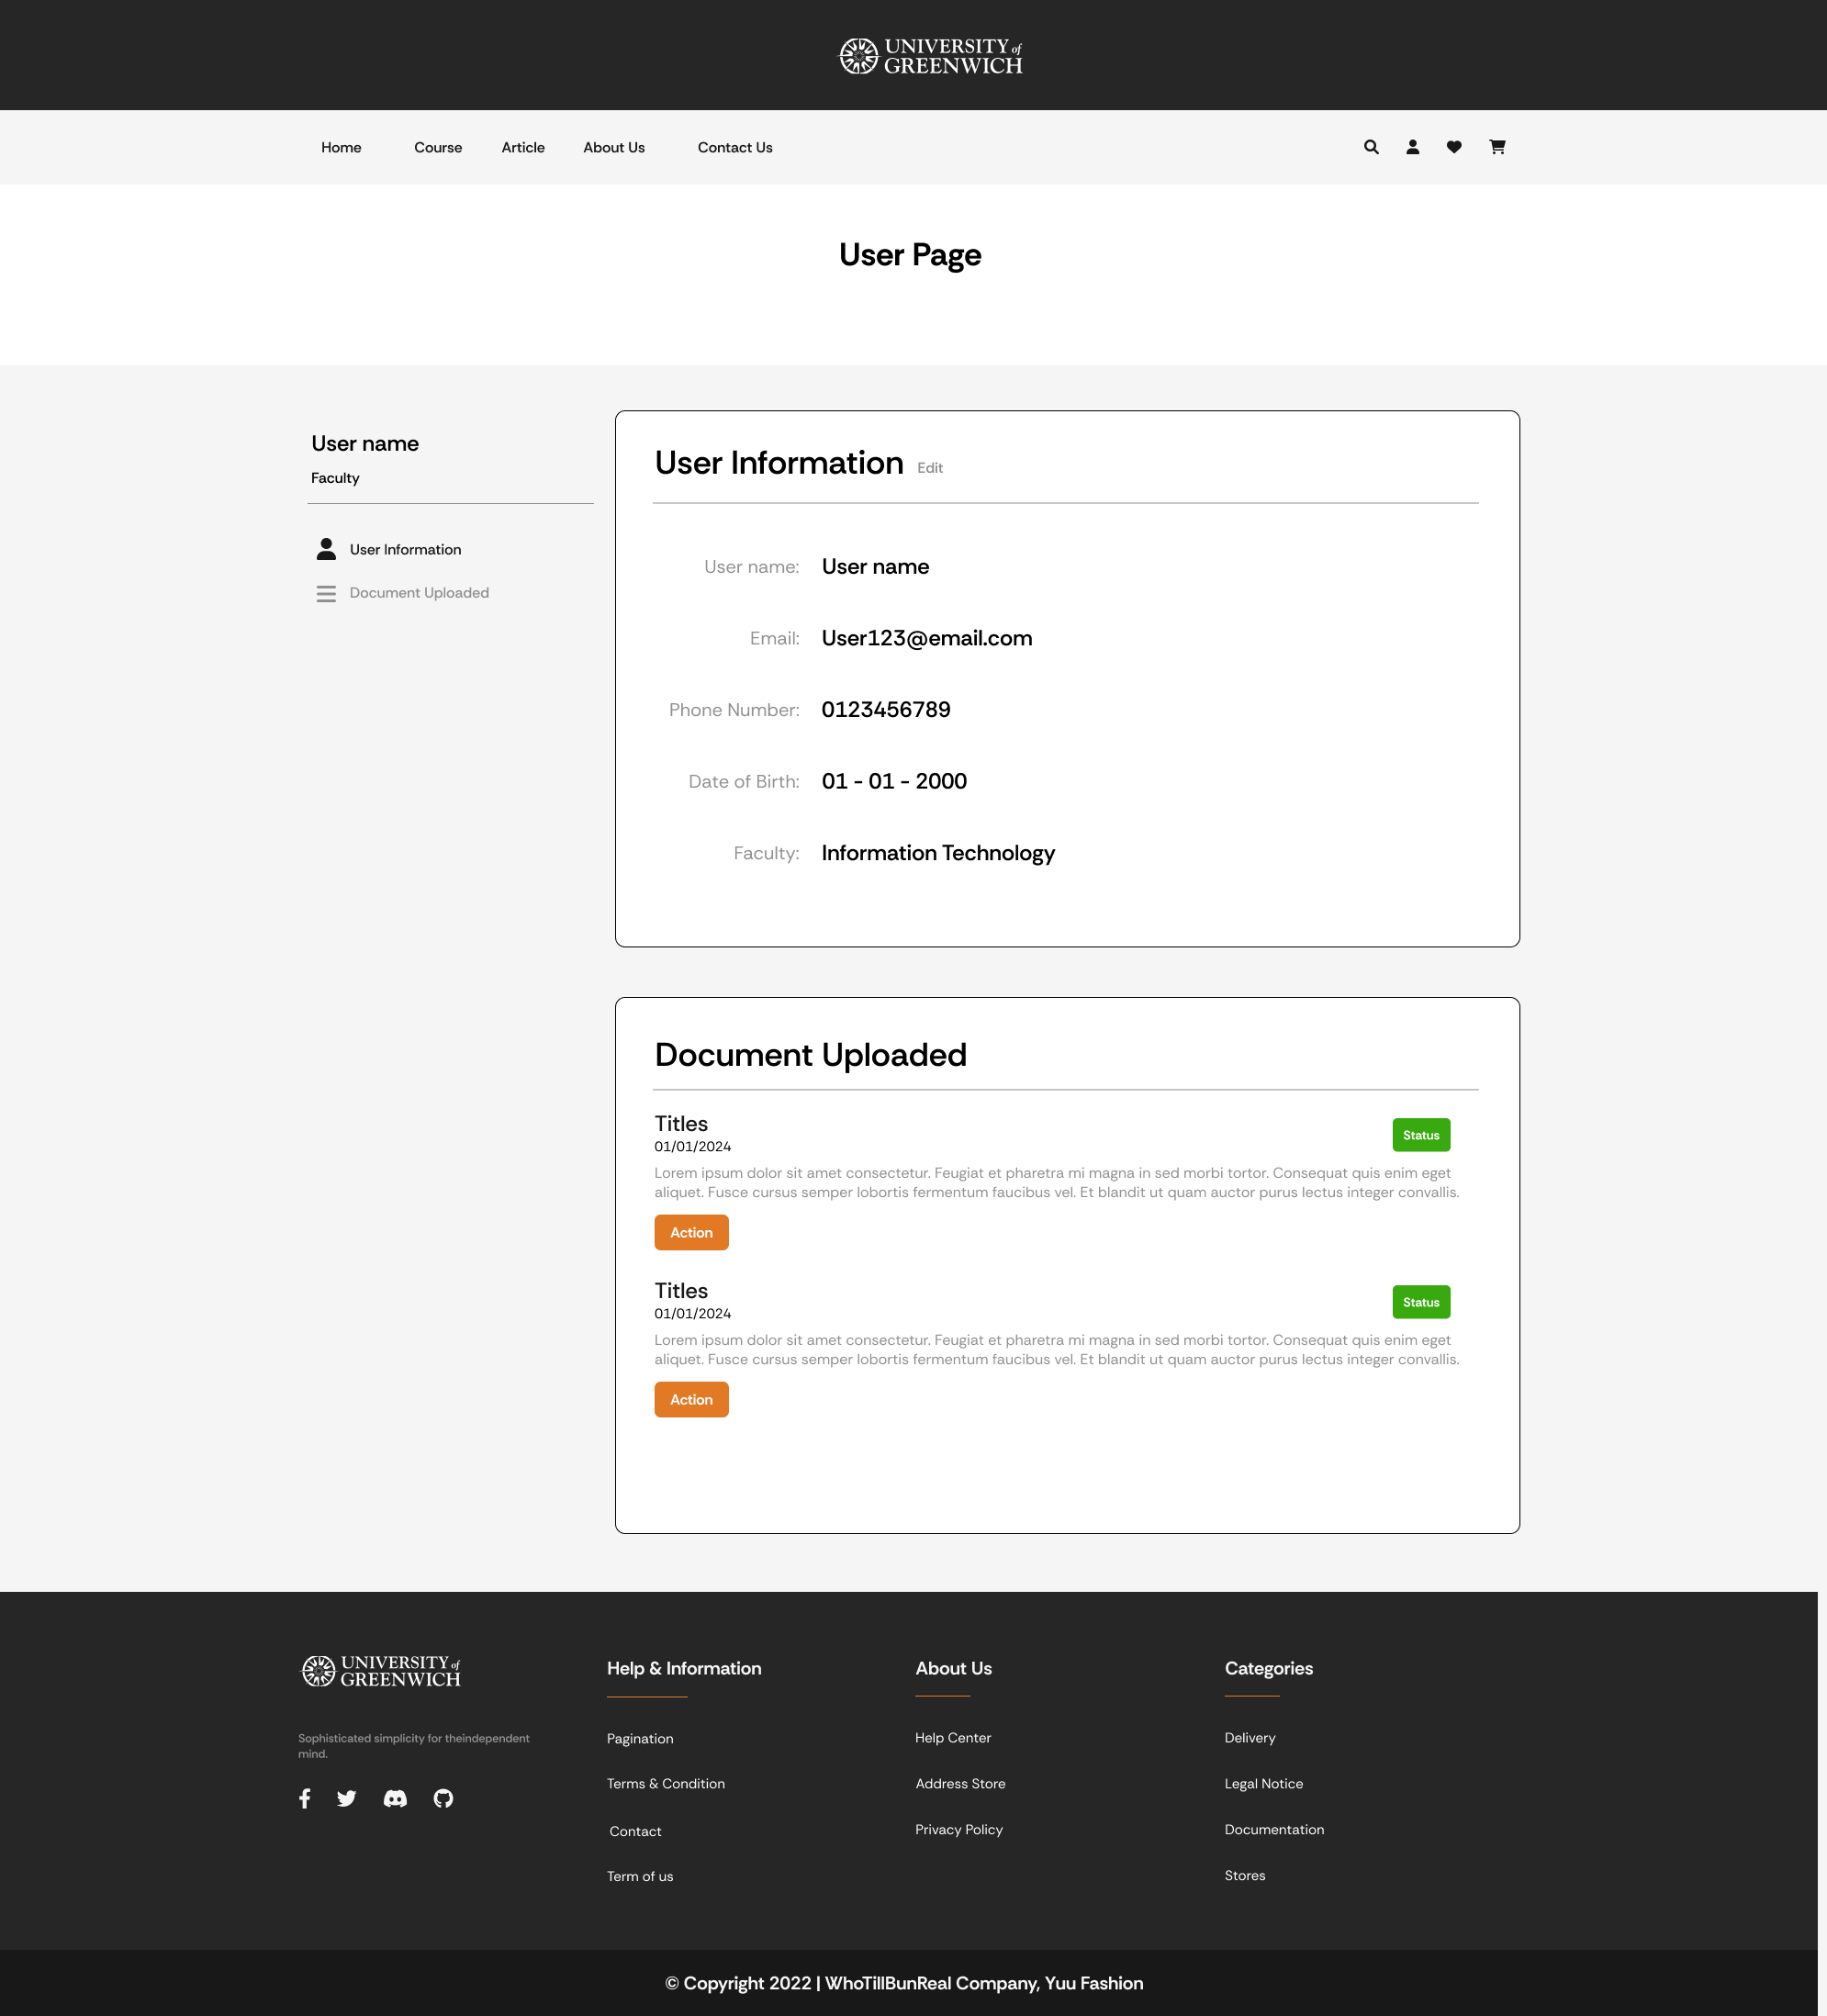

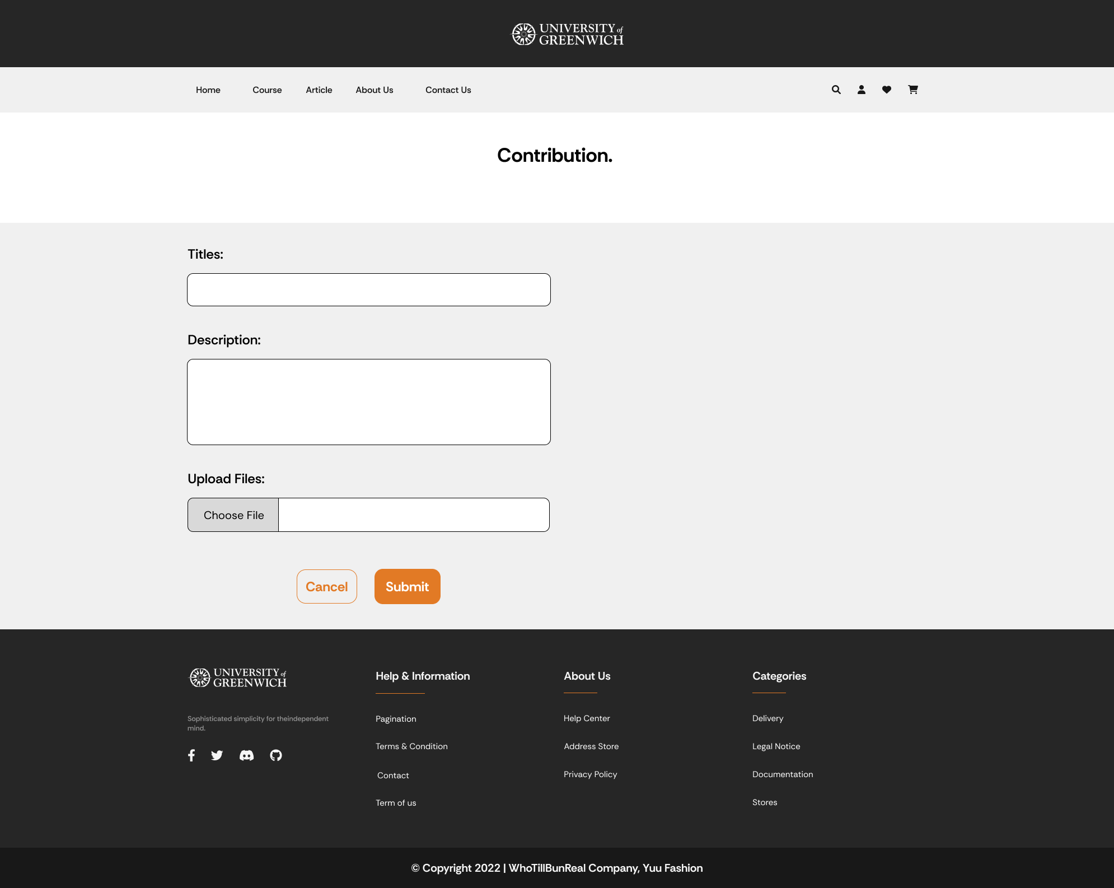

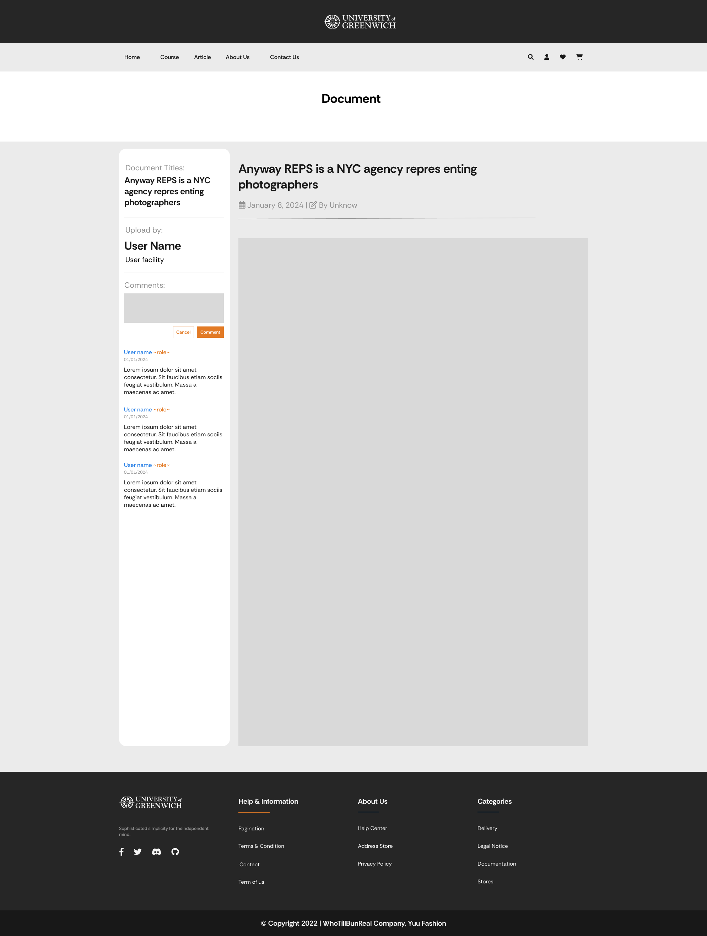

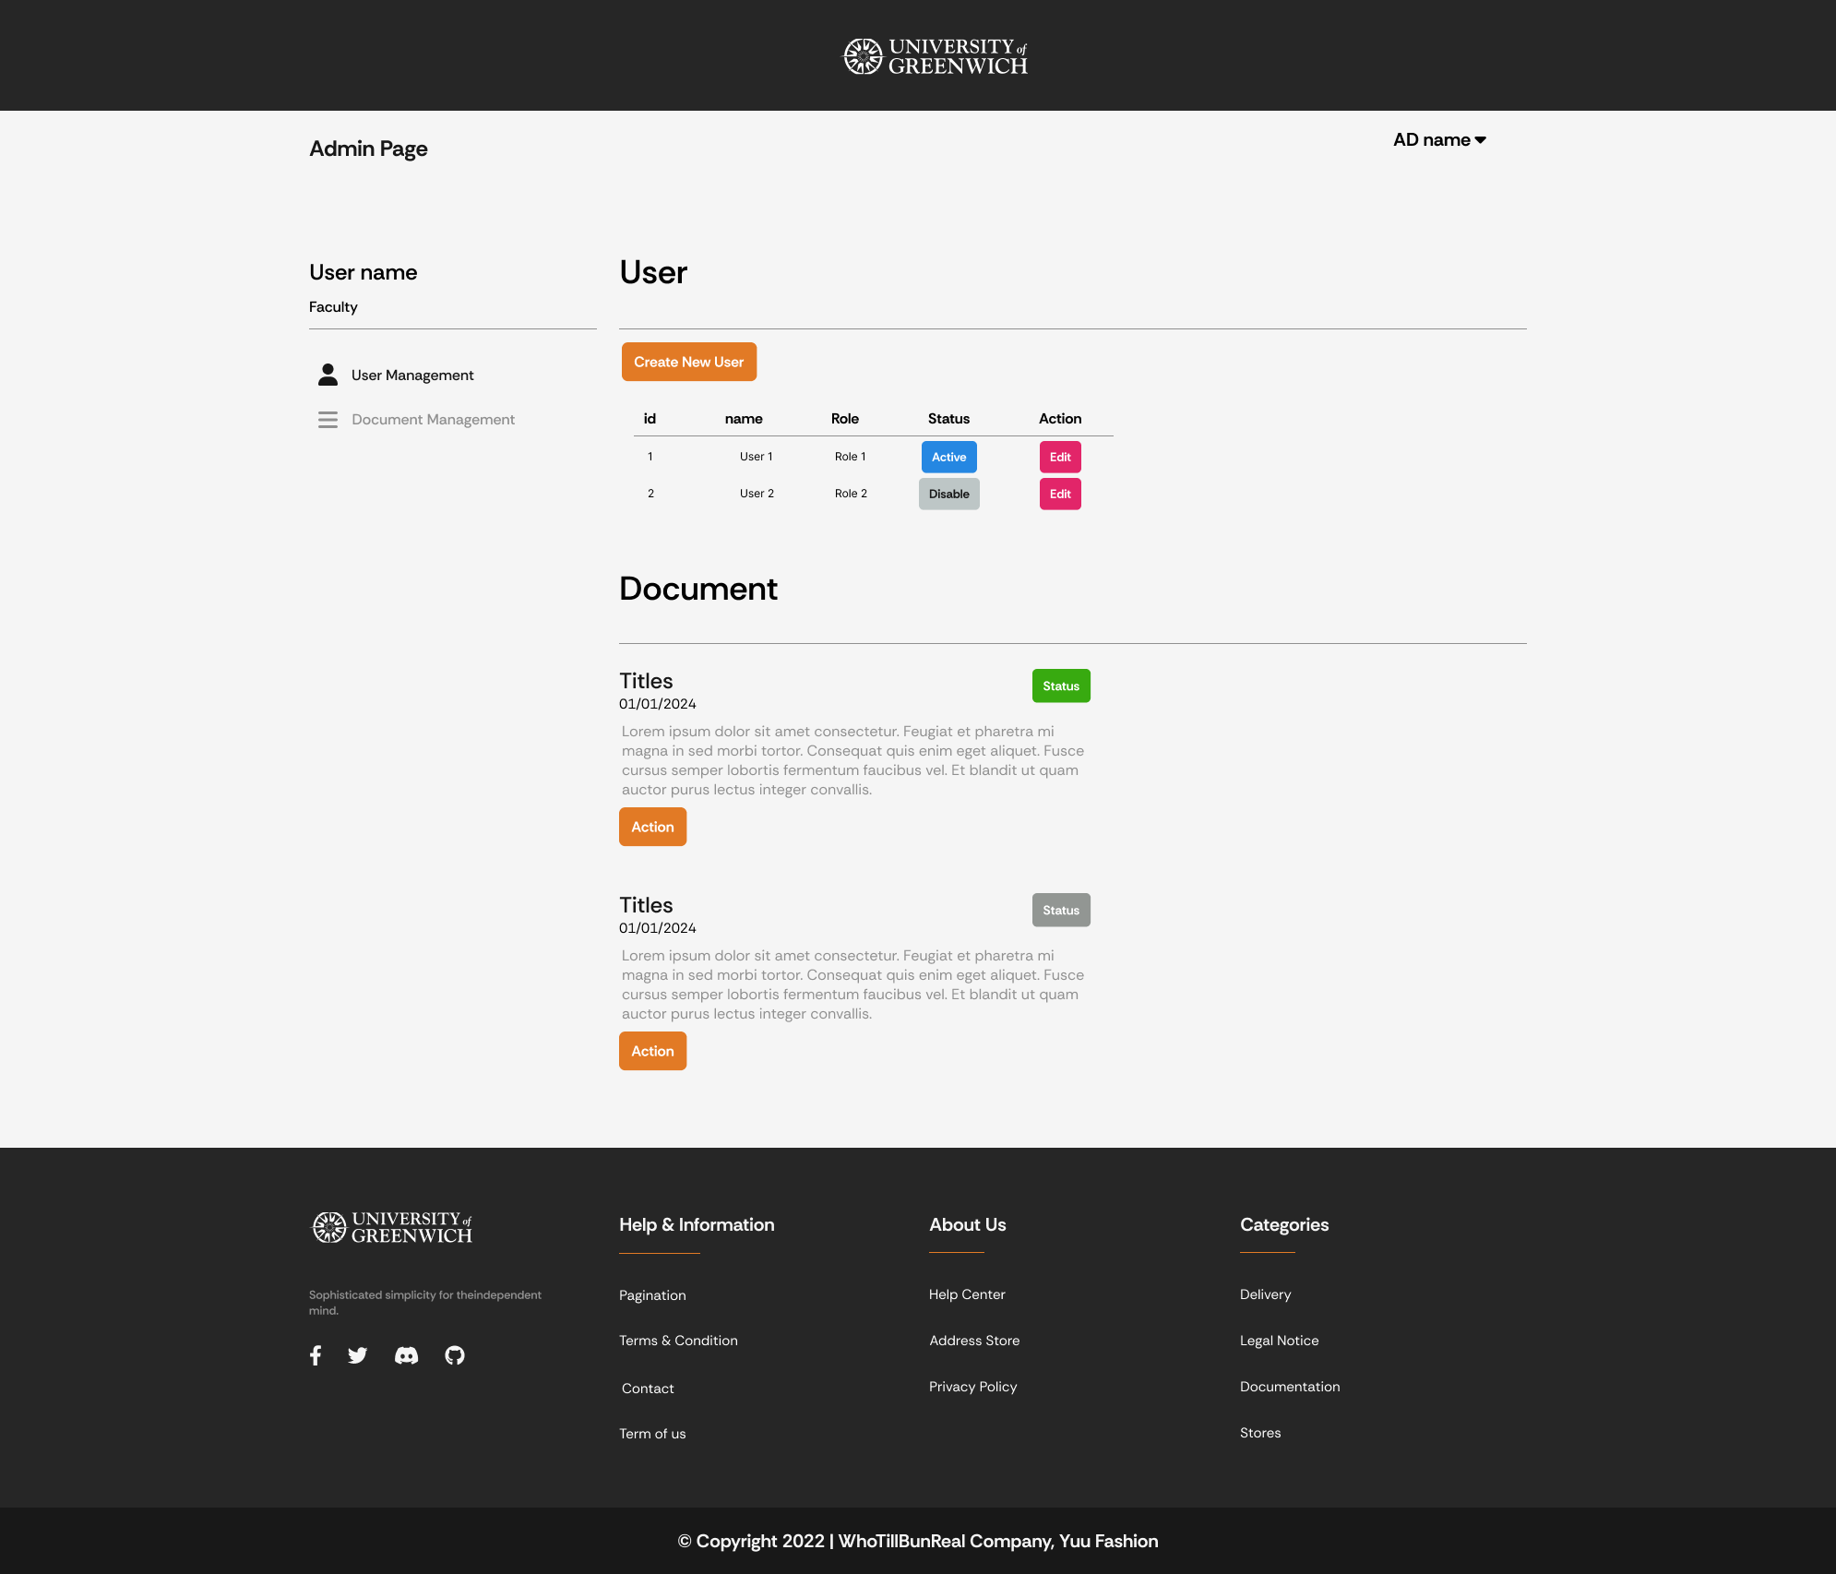

* + 1. Website interface.

After complete front-end and back-end , here is the interface of the website.



Figure 62: Home Page.

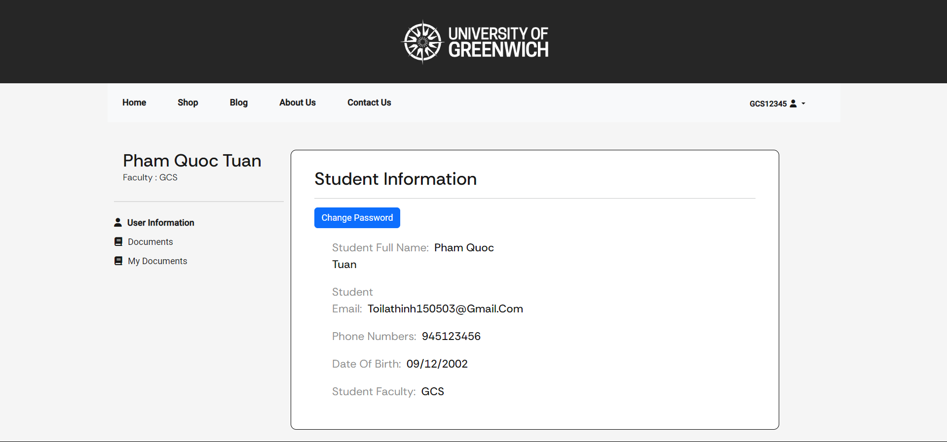

Figure 63: Student information Page.

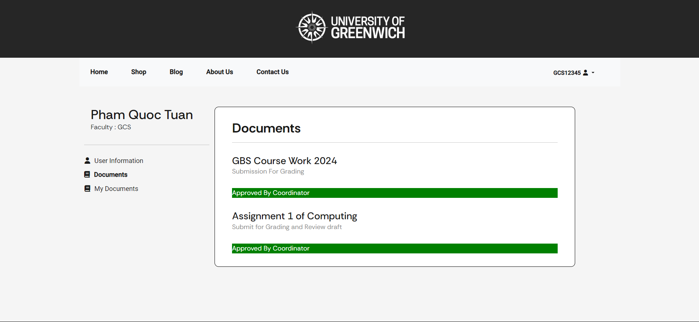

Figure 64: Student Documents View Page.

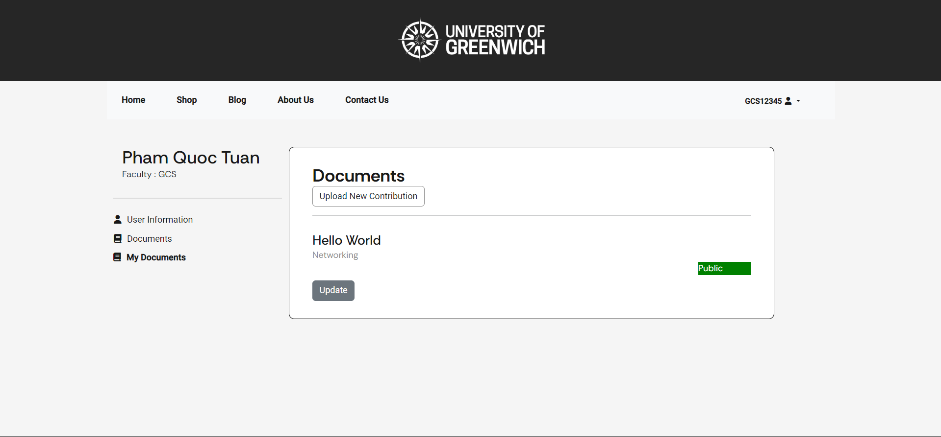

Figure 65: Student My Documents Page.

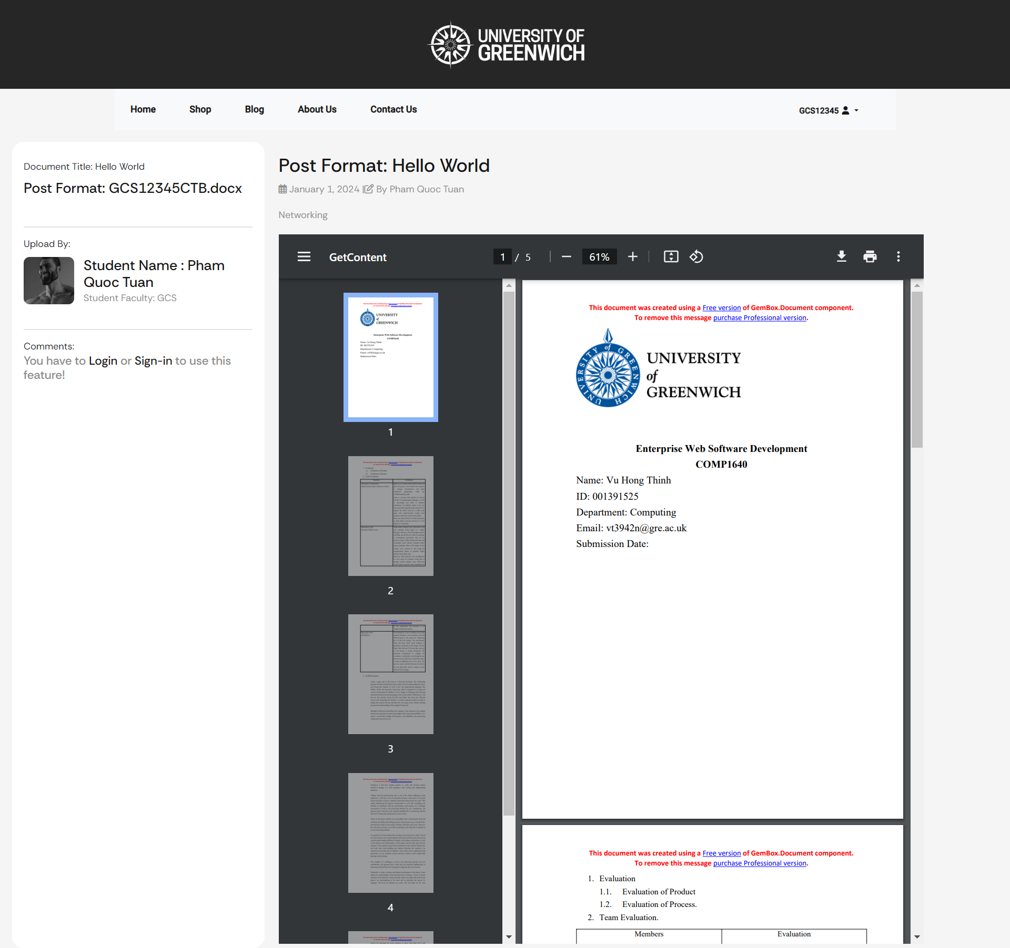

Figure 66: View Content Page.

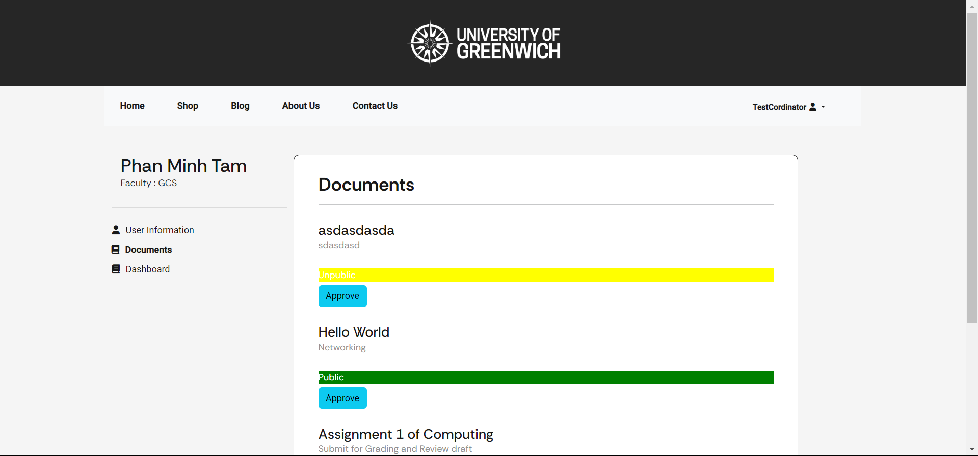

Figure 67: Cordinator Documents View Page.

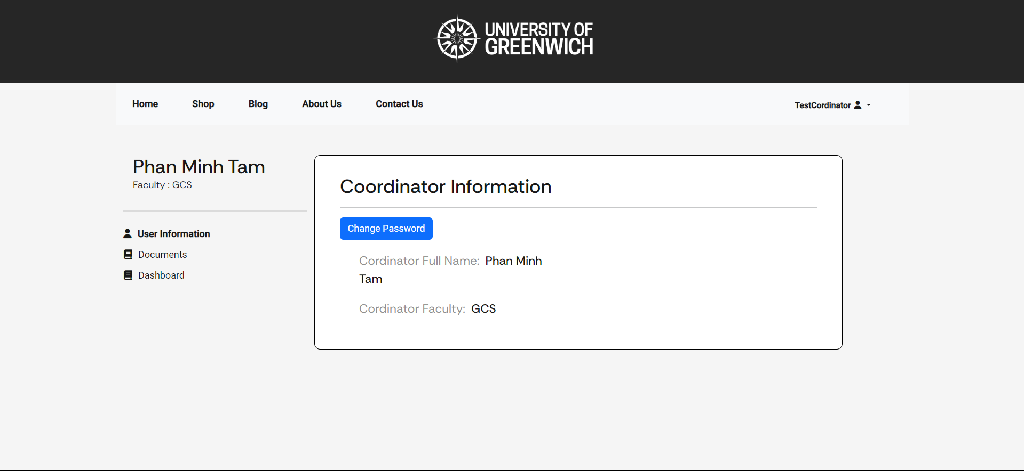

Figure 68: Cordinator Information Page.

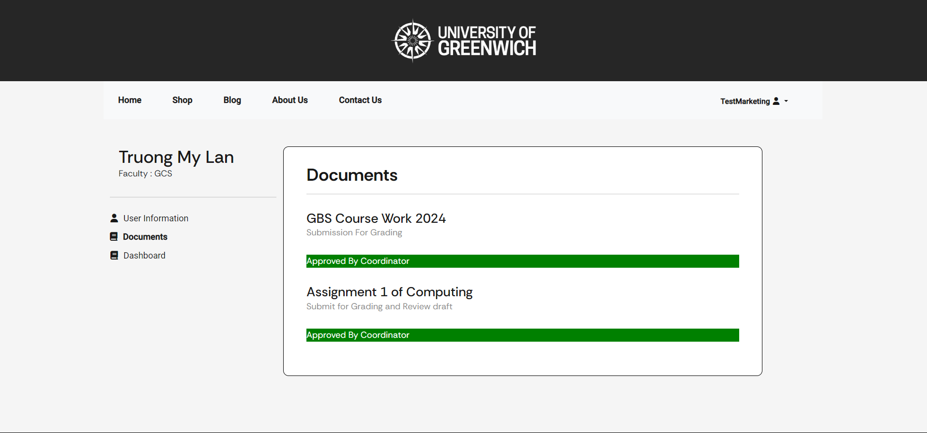

Figure 69: Marketing Cordinator Documents View Page base on Faculty.

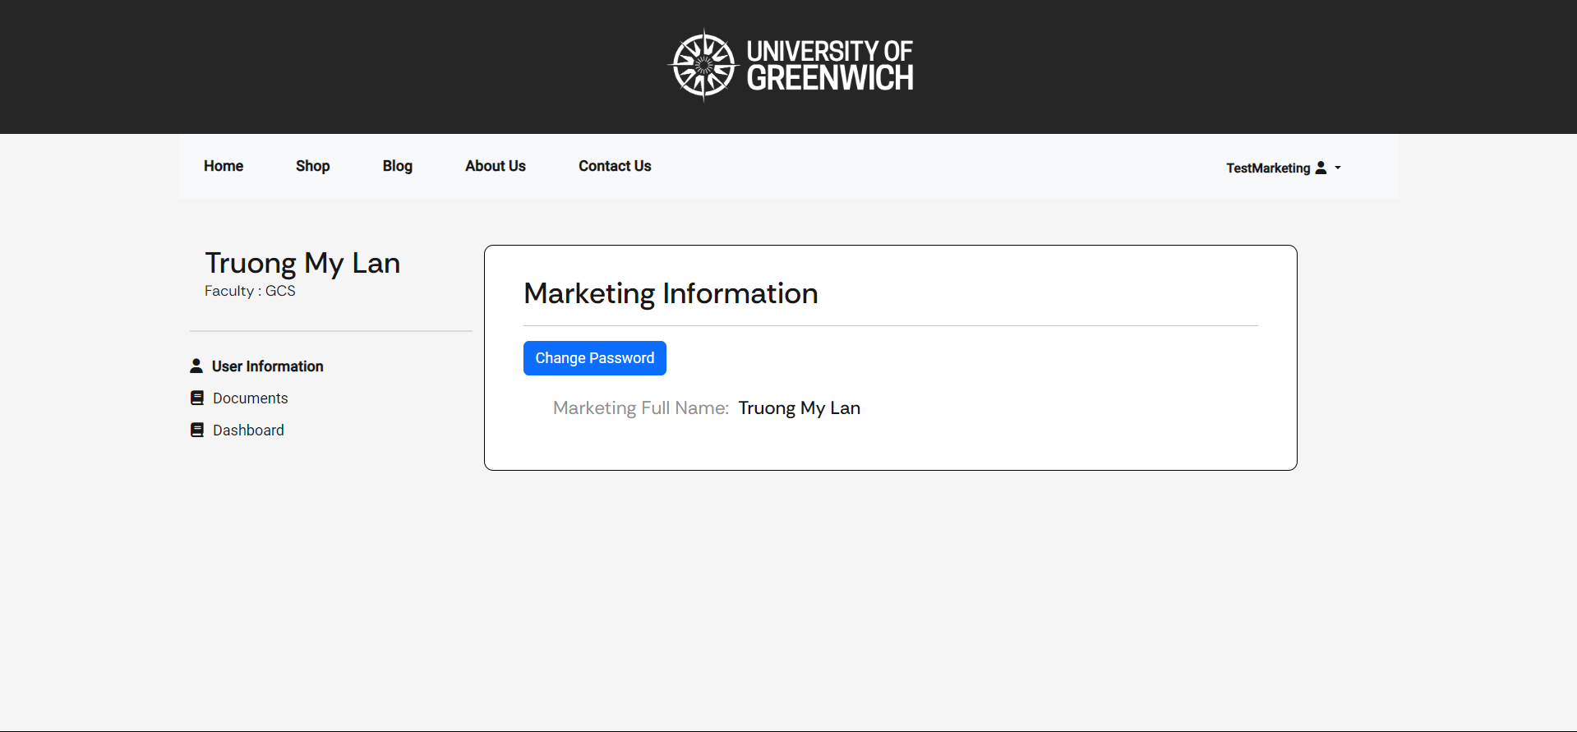

Figure 70: Marketing Cordinator information.

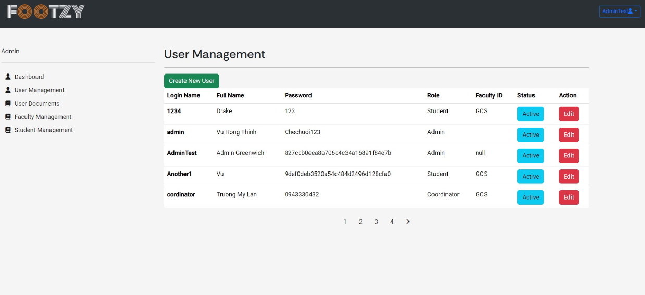

Figure 71: Admin Interface for Manage user

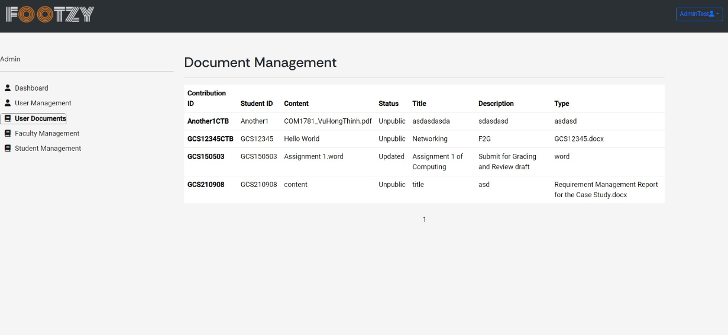. Figure 72: Admin Interface for view document management

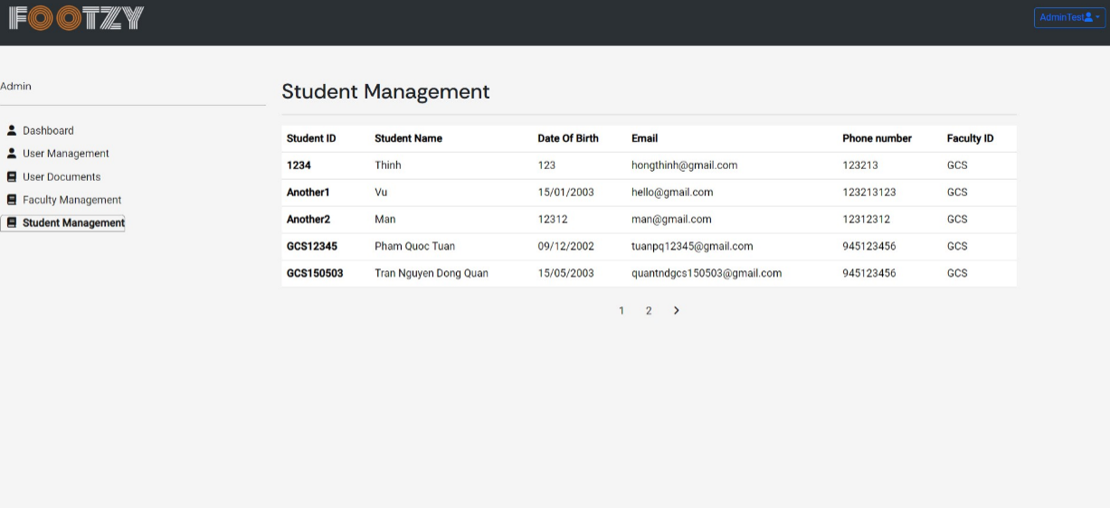

Figure 73: Admin Interface for view Student Management

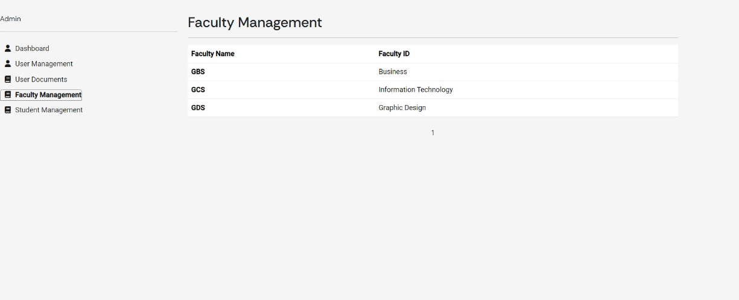

Figure 74: Admin Interface for view Faculty Management

6.2.3 Front-end Coding:

For front-end programming, the team decided to use angular to develop the website. In addition, during the development process, the team also uses scss to configure html attributes more easily, and also uses the css framework bootstrap to quickly configure html elements.

First, create two scss files named globals and variables.

These 2 files have a common configuration role for all attributes in html. For globals, you will configure properties such as background color, font used for the whole website, and configure common properties for the tags used. The variables file will include properties such as naming colors for convenience in use, or configuring mixin properties.

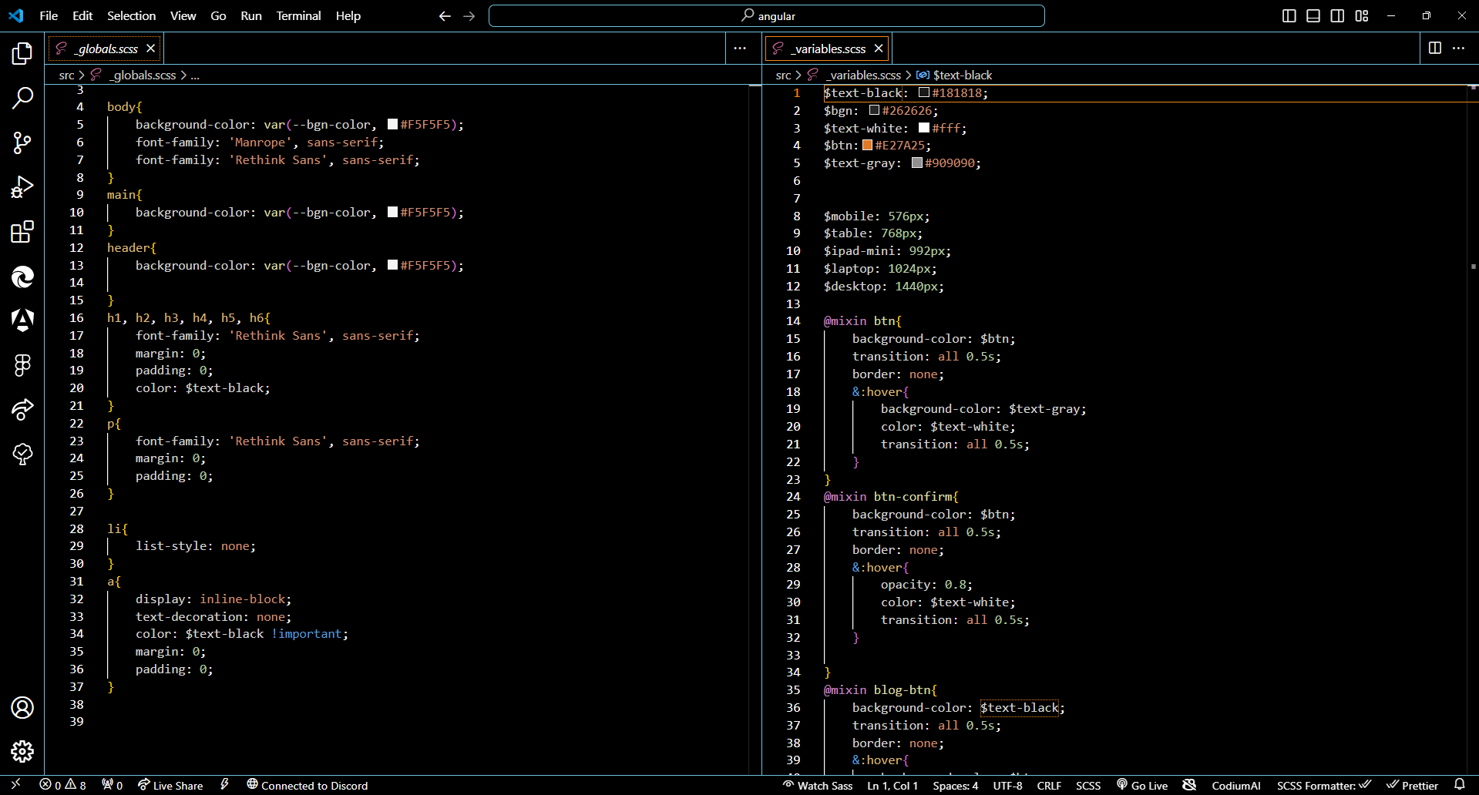

Next is the how front-end handle the connection between it and back-end. We are using Angular Framework for front-end. A programming platform based on TypeScript is called Angular. Angular as a platform consists of A framework based on components for creating scalable web apps a group of tightly coupled libraries covering many different functions, such as forms management, routing, client-server communication, and more a group of tools for developers to aid in the creation, testing, and updating of your code. You may benefit from a platform that scales from one-developer projects to enterprise-level apps by using Angular. The best part is that over 1.7 million developers, library authors, and content producers make up the rich Angular ecosystem.

Here is how Angular handle all of the events and handle data , connection to api of back-end.

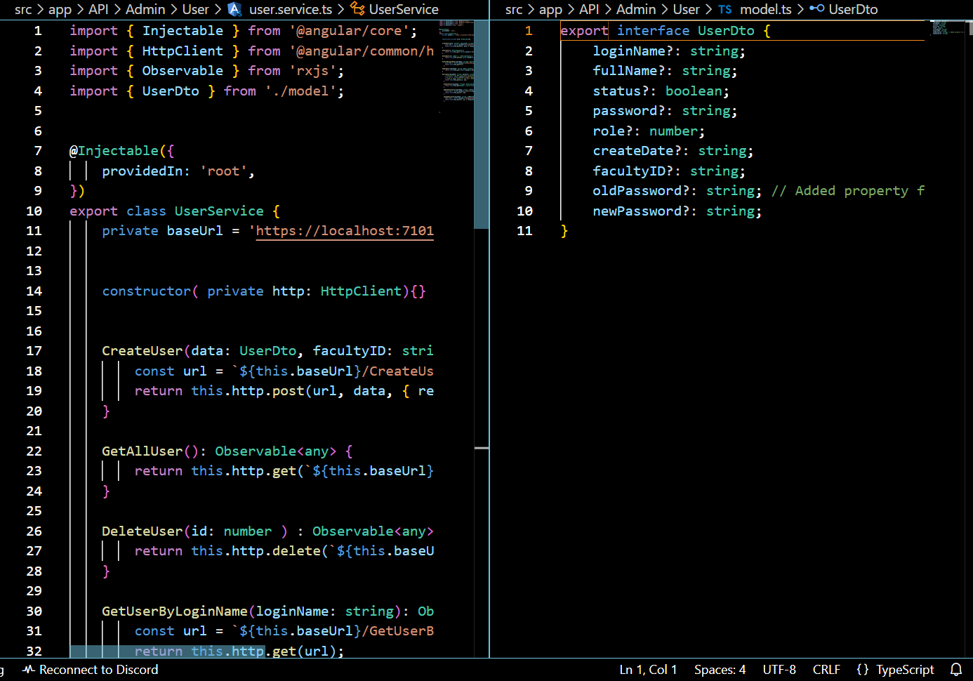

Figure 75: File service and file DTO of Angular.

First of all, we need to create a service folder for connect api from back-end. Next is the file for calling out the DTO in the back-end. After created all the service function as needed, we can manage, modify all the events and the handle problem in the website by using the component inside of the angular project. It have a lots of package and typescript is the language that help a lots for developer to make all the events. And when we import something we need to import the module into the file app.module.ts for using the pakage of angular.

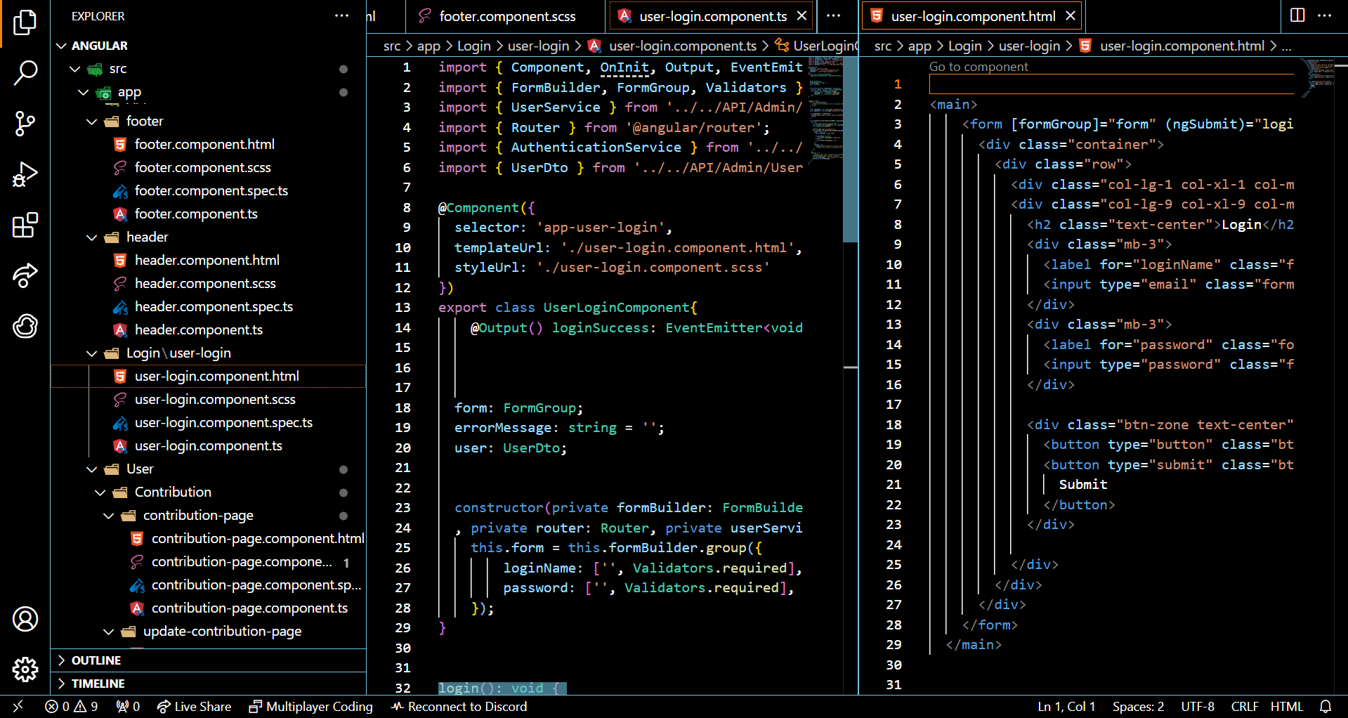

Figure 76: User Component ( typescript and html file )

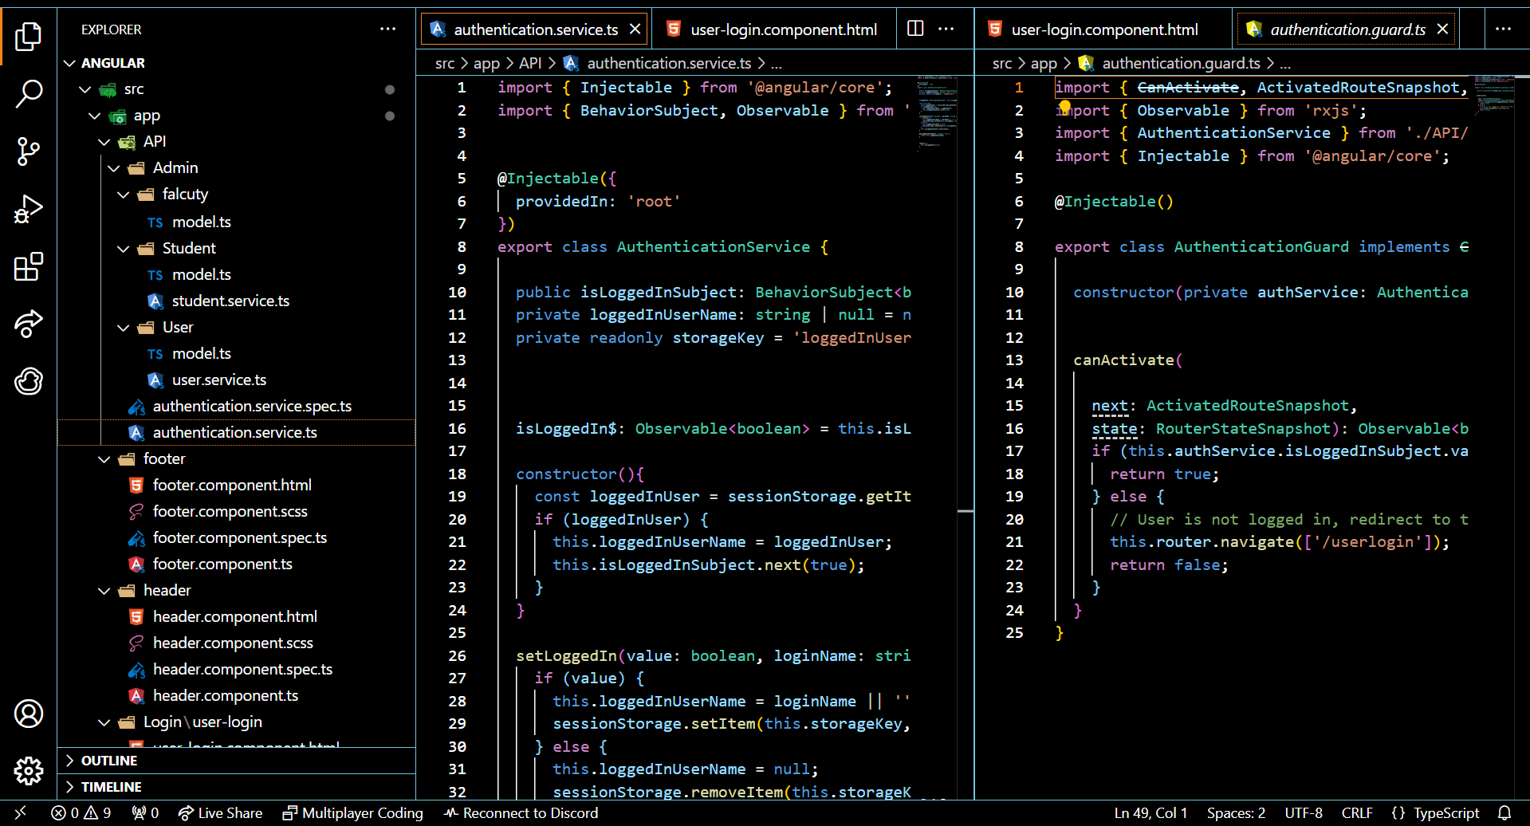

Figure 77: Authentication Guard ( typescript and html file )

And of course, one of the example is the authentication in the website. Angular framework support this also. We could create the service file to call out the authentication and then make the auth guard for making the route authen.

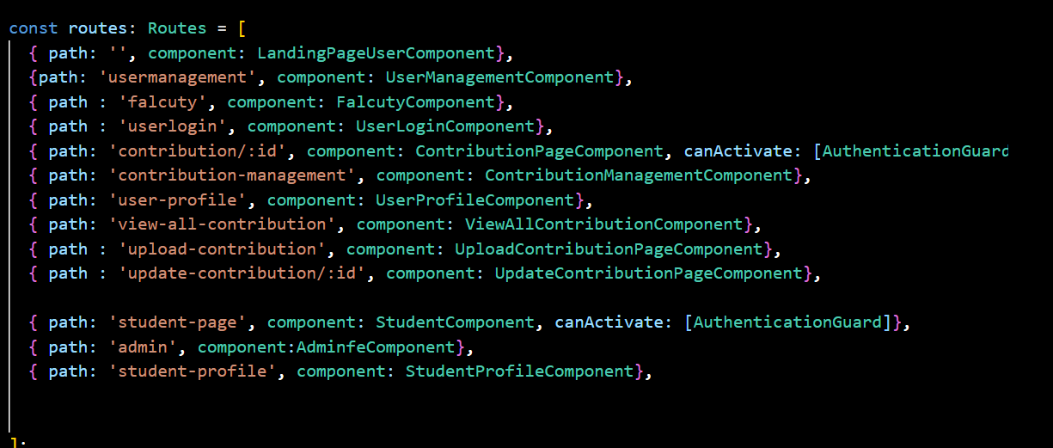  
  
Figure 78: Routing of Angular

And of course, Angular have the routing module for developer to use call out the page with that route when have some events in the page.

# Materials

[JKisoTech/COMP1640 (github.com)](https://github.com/JKisoTech/COMP1640)

<https://drive.google.com/drive/folders/1MFDAOL-U3-doX3Wtmc6cCrXRgZQ4R-IV?usp=sharing>

# References

Ardal, T. (2022) *How to send emails from c#/.net - the definitive tutorial*, *elmah.io Blog - .NET Technical tutorials/guides and new features*. Available at: https://blog.elmah.io/how-to-send-emails-from-csharp-net-the-definitive-tutorial/ (Accessed: 24 April 2024).

Khan, S.M.A. (no date) *Three tier architecture in ASP.NET CORE 6 web api*, *C# Corner*. Available at: https://www.c-sharpcorner.com/article/three-tier-architecture-in-asp-net-core-6-web-api/ (Accessed: 24 April 2024).